H-1: Subscribers generate higher customer value than non-subscribers

- Metrics used:
CVS, HRP, PCS, FPLS, Sub
- Why these metrics?
CVS → overall value
HRP → historical contribution
PCS → premium quality
FPLS → value without discount dependence

- Insight Path
Sub
↓
Value Metrics
↓
Does subscription create valuable customers?

- Query:

SELECT
Sub,
ROUND(AVG(CVS),4) AS Avg_CVS,
ROUND(AVG(HRP),2) AS Avg_HRP,
ROUND(AVG(PCS),4) AS Avg_PCS,
ROUND(AVG(FPLS),4) AS Avg_FPLS,
COUNT(*) AS Customers
FROM `master dataset`
GROUP BY Sub
ORDER BY Sub DESC;

- Result:
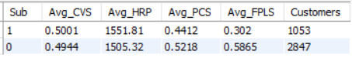
- Evidence:
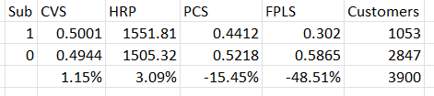
- Subscribers show only 1.15% higher overall customer value (CVS).
- Subscribers show only 3.09% higher historical revenue (HRP).
- Subscribers have 15.45% lower Premium Customer Score (PCS).
- Subscribers have 48.51% lower Full Price Loyalty Score (FPLS).

- Decision:
Rejected
The hypothesis states that subscribers generate higher customer value than non-subscribers.
While subscribers marginally outperform on CVS and HRP, the differences are extremely small. More importantly:
- PCS is significantly lower.
- FPLS is dramatically lower.
Since PCS and FPLS are stronger indicators of customer quality and sustainable value than raw spending alone, the evidence does not support the hypothesis.

- Preliminary Insight:
The current subscription program does not appear to attract the highest-quality customers. Subscribers spend slightly more on average, but they exhibit substantially lower premium-customer characteristics and significantly lower full-price loyalty. This suggests that the subscription offering may be appealing more to deal-seeking or promotion-dependent customers rather than genuinely loyal, high-value customers.

H-2: Customers with higher purchase frequency generate higher customer value

- Metrics used:
CVS, PCS, Freq_norm, Frequency of Purchases
- Insight Path
Frequency
↓
CVS / PCS
↓
Does engagement drive value?

- Query:

SELECT
`Frequency of Purchases`,
ROUND(AVG(CVS),4) AS Avg_CVS,
ROUND(AVG(PCS),4) AS Avg_PCS,
COUNT(*) AS Customers
FROM `master dataset`
GROUP BY `Frequency of Purchases`
ORDER BY Avg_CVS DESC;

- Result:
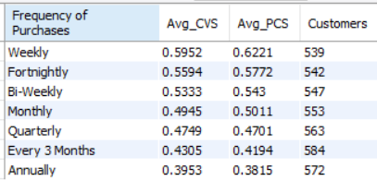

- Evidence:

Weekly purchasers exhibit 50.57% higher Customer Value Scores and 63.07% higher Premium Customer Scores compared to annual purchasers. Additionally, both metrics decline almost perfectly as purchase frequency decreases.

- Decision:
Strongly Accepted
Customers who purchase more frequently consistently exhibit:
- Higher Customer Value Scores (CVS)
- Higher Premium Customer Scores (PCS)

- Preliminary Insight:
Purchase frequency appears to be one of the strongest drivers of customer value in the business. Customers who interact with the brand more frequently not only spend more value-wise but also display significantly stronger premium-customer characteristics. This suggests that increasing purchase frequency may be a more effective growth lever than increasing subscription adoption, as frequency demonstrates a much stronger relationship with customer value than the subscription program observed in H1.

H-3: Veteran customers contribute disproportionately to total customer value

- Metrics used:
CVS, PCS, HRP, Tenure_Tier
- Insight Path:
Customer Lifecycle Stage
↓
Value Contribution
↓
Which lifecycle stage matters most?

- Query:

SELECT
Tenure_Tier,
ROUND(AVG(HRP),2) AS Avg_HRP,
ROUND(AVG(CVS),4) AS Avg_CVS,
ROUND(AVG(PCS),4) AS Avg_PCS,
COUNT(*) AS Customers
FROM `master dataset`
GROUP BY Tenure_Tier
ORDER BY Avg_HRP DESC;

- Result:
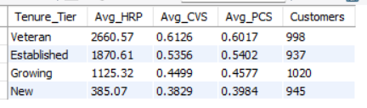

- Evidence:
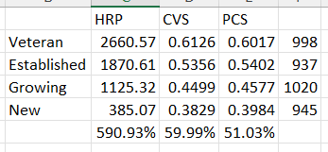
The decline is almost perfectly monotonic:
Veteran
↓
Established
↓
Growing
↓
New
for all three metrics:
HRP ↓
CVS ↓
PCS ↓

- Decision:
Strongly Accepted
Customer value, premium-customer quality, and historical revenue all increase consistently with customer tenure. The relationship is systematic and substantial, particularly for HRP where Veteran customers contribute nearly 6 times the historical revenue of New customers.
- Preliminary Insight:
Customer tenure is a major determinant of customer value. As customers mature through their lifecycle, they become significantly more valuable, contribute more revenue, and exhibit stronger premium-customer characteristics. This suggests that retaining customers long enough to move them from New and Growing stages into Established and Veteran stages may be one of the most powerful long-term value creation strategies available to the business.

H-4: A small percentage of customers generate a majority of customer value

- Metrics
•CVS
•PCS
•HRP
- Insight Path
Customer Ranking
↓
Value Concentration
↓
Does a Pareto effect exist?

- Query:
SELECT
`Customer ID`,
ROUND(CVS,4) AS CVS,
ROUND(PCS,4) AS PCS,
ROUND(HRP,2) AS HRP
FROM `master dataset`
ORDER BY CVS DESC
LIMIT 20;

- Result:
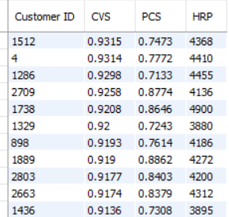
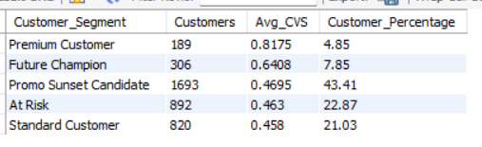
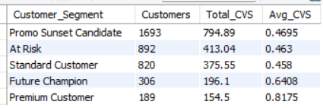

- Evidence:
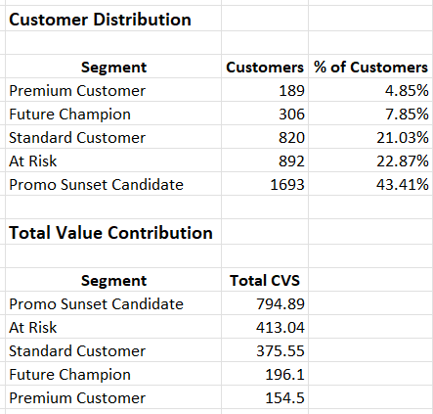
Key calculations:
- Premium Customers + Future Champions = 12.70% of customers
- Their combined Total CVS = 350.60
- Total CVS across all customers = 1934.08
- Contribution = 18.13% of total customer value
Additionally:
- The largest segment (Promo Sunset Candidate) represents 43.41% of customers and contributes 41.10% of total value.
- Value contribution broadly follows customer distribution rather than being concentrated among a small elite group.

- Decision:
Rejected
The data does not support a strong Pareto-style concentration of value.
If the hypothesis were true, we would expect a small percentage of customers (e.g., top 10–20%) to contribute a disproportionately large share (50–80%+) of total value.
Instead:
- 12.7% of customers contribute only 18.1% of total value.
- The largest customer segment also contributes the largest share of value.
- Customer value appears relatively distributed across the customer base.

- Preliminary Insight:
The business does not appear to be heavily dependent on a small group of elite customers. Unlike many premium D2C businesses where a small customer cohort generates most of the revenue and value, this customer base exhibits a relatively broad value distribution. This suggests that growth and retention strategies should focus on improving the value of large customer cohorts rather than concentrating exclusively on a narrow group of top customers.

Cross-Hypothesis Observation (Very Important)
After H1-H4:
Hypothesis | Result
H1 | Subscription is not a strong value driver
H2 | Purchase Frequency is a strong value driver
H3 | Customer Tenure is a strong value driver
H4 | Value is broadly distributed, not concentrated
A narrative is emerging:
Value is created by
customer behaviour and maturity
NOT
by subscription membership
or a tiny elite customer group.

H-6: Subscribers exhibit stronger loyalty than non-subscribers

- Metrics used:
BLS_TEMP, QLS, FPLS, Sub
- Insight Path:
Subscription Status
↓
Behavioral Loyalty (BLS_TEMP)
↓
Quality Loyalty (QLS)
↓
Full Price Loyalty (FPLS)
↓
Does Subscription Actually Create Loyalty?

- Query:

SELECT
Sub,
ROUND(AVG(BLS_TEMP),4) AS Avg_BLS,
ROUND(AVG(QLS),4) AS Avg_QLS,
ROUND(AVG(FPLS),4) AS Avg_FPLS,
COUNT(*) AS Customers
FROM `master dataset`
GROUP BY Sub
ORDER BY Sub DESC;

- Result:
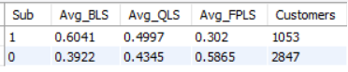

- Evidence:
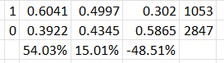
Supporting Evidence
Subscribers score:
- 54.0% higher on Behavioral Loyalty
- 15.0% higher on Quality Loyalty
This suggests subscribers engage more frequently and appear more loyal on traditional loyalty metrics.
Contradicting Evidence
Subscribers score:
- 48.5% lower on Full Price Loyalty
This is a very large negative gap.
FPLS is designed to measure loyalty that survives without promotional incentives.
Therefore, subscribers appear loyal, but not organically loyal

- Decision:
Partially Supported
Because the answer depends on which loyalty definition we trust.
- Preliminary Insight:
Subscribers demonstrate significantly stronger behavioral and quality-adjusted loyalty than non-subscribers, indicating that they engage more frequently with the brand and exhibit stronger repeat-purchase patterns. However, their dramatically lower Full Price Loyalty Score suggests that this loyalty may be dependent on incentives, benefits, or promotional mechanisms embedded within the subscription program. In other words, the subscription program appears successful at increasing engagement, but may not be creating genuinely promotion-independent loyalty.

- Cross-Hypothesis Observation:
Compare H1 and H6:

H1
Subscribers
↓
Slightly Higher CVS
Much Lower PCS
Much Lower FPLS
H6
Subscribers
↓
Much Higher BLS
Higher QLS
Much Lower FPLS

A very interesting pattern is emerging:
Subscription = Strong Engagement Driver
BUT
Not a Strong Organic Loyalty Driver

H-7: Frequent purchasers are more loyal

- Metrics:
Frequency of Purchases, BLS_TEMP, QLS, FPLS
- Insight Path:
Purchase Frequency
↓
Behavioural Loyalty
↓
Quality Loyalty
↓
Full Price Loyalty
↓
Does Engagement Create Genuine Loyalty?

- Query:
SELECT
`Frequency of Purchases`,
ROUND(AVG(BLS_TEMP),4) AS Avg_BLS,
ROUND(AVG(QLS),4) AS Avg_QLS,
ROUND(AVG(FPLS),4) AS Avg_FPLS,
COUNT(*) AS Customers
FROM `master dataset`
GROUP BY `Frequency of Purchases`
ORDER BY Avg_BLS DESC;
- Result:
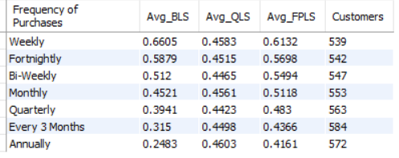
- Evidence:
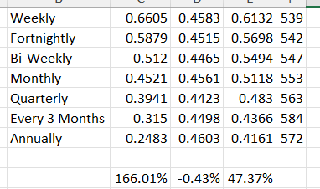
Weekly purchasers exhibit 165.93% higher Behavioral Loyalty than annual purchasers.
Weekly purchasers exhibit 47.37% higher Full Price Loyalty than annual purchasers.
QLS remains relatively stable across frequency groups.

- Decision:
Strongly Accepted
Purchase frequency is strongly associated with loyalty.
The evidence is especially strong for:
- Behavioral Loyalty (BLS)
- Full Price Loyalty (FPLS)
The relationship is systematic and substantial.

- Preliminary Insight:
Customers who purchase more frequently demonstrate significantly stronger loyalty, particularly in terms of repeat-purchase behavior and loyalty that persists without promotional dependence. The nearly perfect decline in both BLS and FPLS across frequency groups suggests that purchase frequency is one of the strongest observable indicators of customer loyalty in the business.
- Cross-Hypothesis Observation:
After H2, H5, H6, and H7:
Driver | Evidence Strength
Subscription | Mixed
Purchase History | Moderate
Purchase Frequency | Very Strong

Current evidence is increasingly supporting:
Frequency > Purchase History > Subscription
as the hierarchy of loyalty drivers.
This also strengthens the conclusion from H5 that BLS_C (frequency-weighted loyalty model) is likely the most representative loyalty framework among the three BLS variants.

H8: Quality Loyalty explains customer value better than Behavioral Loyalty

- Metrics:
QLS, BLS_TEMP, CVS, PCS
- Insight Path:
Behavioral Loyalty
vs
Quality Loyalty
↓
Customer Value
↓
Which Loyalty Framework Better Explains Value?

- Query:
SELECT
Customer_Segment,
ROUND(AVG(BLS_TEMP),4) AS Avg_BLS,
ROUND(AVG(QLS),4) AS Avg_QLS,
ROUND(AVG(CVS),4) AS Avg_CVS,
ROUND(AVG(PCS),4) AS Avg_PCS,
COUNT(*) AS Customers
FROM `master dataset`
GROUP BY Customer_Segment
ORDER BY Avg_CVS DESC;

- Result:
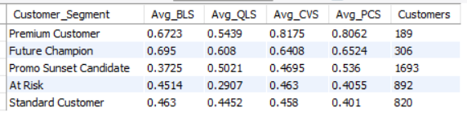
- Evidence:
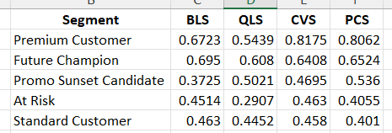
- Premium and Future Champion segments score highly on BOTH metrics.
- Low-value segments score lower on BOTH metrics.
- Both metrics track customer value reasonably well.

- Decision:
Rejected
The evidence does not support the claim that Quality Loyalty explains customer value better than Behavioral Loyalty.
Instead:
BLS ≈ QLS
Both loyalty frameworks appear strongly associated with customer value.
In fact, BLS shows slightly cleaner separation among customer segments because it aligns closely with the two strongest value drivers discovered so far:
- Purchase Frequency (H2)
- Customer Maturity (H3)

- Preliminary Insight:
Customer value appears to be driven by a combination of behavioral engagement and quality-based loyalty rather than by quality loyalty alone. Behavioral Loyalty remains a powerful explanatory metric because it captures the frequency and consistency of customer interaction with the brand, both of which have already emerged as strong value drivers. Quality Loyalty adds useful context, but it does not outperform Behavioral Loyalty in explaining customer value.
- Cross-Hypothesis Observation:
After H2, H3, H5, H7, and H8:
Purchase Frequency
↓
Strong Value Driver

Purchase Frequency
↓
Strong Loyalty Driver

BLS_C
↓
Best Loyalty Model

Behavioral Loyalty
↓
Explains Value Well
This is actually strengthening H5.
The overall narrative emerging is:
Customer Value
← Customer Maturity
← Purchase Frequency
← Behavioral Loyalty

H9: Discount users are less loyal than non-discount users

- Metrics:
QLS, FPLS, DISC, PIS, BLS_TEMP
- Insight Path:
Discount Usage
↓
Behavioral Loyalty
↓
Quality Loyalty
↓
Full Price Loyalty
↓
Does Discounting Create Loyal Customers?

- Query:
SELECT
Disc,
ROUND(AVG(BLS_TEMP),4) AS Avg_BLS,
ROUND(AVG(QLS),4) AS Avg_QLS,
ROUND(AVG(FPLS),4) AS Avg_FPLS,
ROUND(AVG(PIS),4) AS Avg_PIS,
COUNT(*) AS Customers
FROM `master dataset`
GROUP BY Disc
ORDER BY Disc;

- Result:
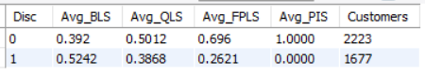
- Evidence:
Discount users exhibit 33.72% higher Behavioral Loyalty.
Non-discount users exhibit 29.57% higher Quality Loyalty.
Non-discount users exhibit 165.55% higher Full Price Loyalty.

- Decision:
Accepted
Although discount users appear more loyal on the behavioral metric (BLS), they perform dramatically worse on both:
- Quality Loyalty (QLS)
- Full Price Loyalty (FPLS)
Since the purpose of the hypothesis is to determine whether discount users are genuinely loyal customers, QLS and FPLS are more meaningful than raw behavioral activity.
The evidence strongly suggests that discount-driven customers are less loyal in a sustainable sense.

- Preliminary Insight:
Discounts appear to increase purchasing activity but do not create genuine customer loyalty. Customers who use discounts frequently exhibit higher behavioral loyalty because they purchase more often, but they show significantly weaker quality loyalty and substantially lower full-price loyalty. This suggests that discounts may be stimulating transactions rather than building long-term brand affinity.
- Cross-Hypothesis Observation:
This is the strongest evidence so far for a major emerging theme:
Hypothesis | Key Finding
H1 | Subscribers have much lower FPLS
H6 | Subscribers appear loyal but not organically loyal
H9 | Discount users have dramatically lower FPLS
Together, H1, H6, and H9 are pointing toward:
Incentives = Higher Activity
NOT
Higher Organic Loyalty

H10: Customers purchasing without discounts generate higher customer value

- Metrics:
PIS, CVS, HRP, PCS, FPLS
- Insight Path:
Promotion Independence
↓
Customer Value
↓
Premium Customer Quality
↓
Historical Revenue
↓
Can Organic Customers Create More Value?

- Query:
SELECT
PIS,
ROUND(AVG(CVS),4) AS Avg_CVS,
ROUND(AVG(PCS),4) AS Avg_PCS,
ROUND(AVG(HRP),2) AS Avg_HRP,
ROUND(AVG(FPLS),4) AS Avg_FPLS,
COUNT(*) AS Customers
FROM `master dataset`
GROUP BY PIS
ORDER BY PIS DESC;
- Result:
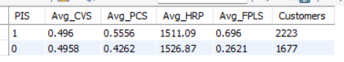
- Evidence:
Practically identical CVS.
Organic customers exhibit substantially stronger premium-customer characteristics.
Practically identical HRP.
Huge gap between organic and discount customers.
- Decision:
Partially Supported
The hypothesis states that customers purchasing without discounts generate higher customer value.
The evidence is mixed:
Supporting
- PCS is 30.35% higher.
- FPLS is 165.55% higher.
Contradicting
- CVS is virtually identical.
- HRP is virtually identical.
Therefore, non-discount customers are clearly higher-quality customers, but not necessarily higher-spending customers.

- Preliminary Insight:
Promotion-independent customers do not spend materially more than discount-driven customers, but they exhibit substantially stronger premium-customer characteristics and dramatically higher full-price loyalty. This suggests that discounts are effective at generating revenue and transactions, but they do not appear to create higher-quality customers. The business may therefore benefit more from increasing the share of promotion-independent customers than from increasing promotional intensity.
- Cross-Hypothesis Observation:
H9 and H10 together reveal something very important:
Metric | Discount Users | Non-Discount Users
Revenue (HRP) | Similar | Similar
Value (CVS) | Similar | Similar
Premium Quality (PCS) | Lower | Higher
Full Price Loyalty (FPLS) | Much Lower | Much Higher
This suggests:
Discounts = Revenue Tool
NOT
Customer Quality Tool

H11: Customers with lower discount dependence have stronger retention potential

- Metrics:
PIS, RPS, CHS, QLS
- Insight Path:
Promotion Independence
↓
Quality Loyalty
↓
Customer Health
↓
Retention Potential
↓
Can Organic Customers Be Retained More Easily?

- Query:
SELECT
PIS,
ROUND(AVG(RPS),4) AS Avg_RPS,
ROUND(AVG(CHS),4) AS Avg_CHS,
ROUND(AVG(QLS),4) AS Avg_QLS,
COUNT(*) AS Customers
FROM `master dataset`
GROUP BY PIS
ORDER BY PIS DESC;

- Result:
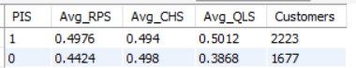
- Evidence:
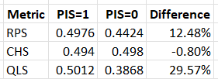
Key observations:
Promotion-independent customers exhibit 12.48% higher Retention Potential Scores (RPS).
Promotion-independent customers exhibit 29.57% higher Quality Loyalty Scores (QLS).
Customer Health Scores (CHS) are virtually identical, with discount users showing a marginal 0.80% advantage.
- Decision:
Partially Supported
The hypothesis is supported by two of the three key metrics:
- RPS indicates stronger retention potential among promotion-independent customers.
- QLS indicates substantially stronger quality loyalty among promotion-independent customers.
- However:
- CHS does not support the hypothesis and remains nearly identical across both groups.
- Therefore, the evidence suggests that lower discount dependence improves retention potential and loyalty quality, but not necessarily overall customer health.

- Preliminary Insight:
Customers who purchase without relying on discounts appear more likely to remain loyal and retainable over the long term. While discount-dependent customers can exhibit comparable overall customer health, promotion-independent customers demonstrate significantly stronger quality loyalty and higher retention potential. This suggests that discounts may help maintain customer activity, but promotion-independent customers form a more stable and sustainable retention base for the business.
- Cross-Hypothesis Observation:
H9, H10, and H11 together now paint a consistent picture:
Discounts
→ Do not materially increase customer value

Discounts
→ Do not materially improve customer health

Discounts
→ Reduce quality loyalty

Discounts
→ Reduce retention potential

Discounts
→ Reduce full-price loyalty

H12: Discount dependency increases as customer maturity decreases

- Metrics:
CMS, PIS, PUF
- Insight Path:
Customer Maturity
↓
Discount Usage
↓
Promotion Independence
↓
Does Maturity Reduce Discount Dependence?

- Query:
SELECT
Tenure_Tier,
ROUND(AVG(CMS),4) AS Avg_CMS,
ROUND(AVG(PUF),4) AS Avg_PUF,
ROUND(AVG(PIS),4) AS Avg_PIS,
COUNT(*) AS Customers
FROM `master dataset`
GROUP BY Tenure_Tier
ORDER BY Avg_CMS DESC;
- Result:
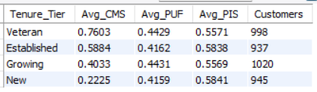
- Evidence:
Key Observation 1
Customer maturity behaves exactly as expected:
Veteran
↓
Established
↓
Growing
↓
New
CMS declines perfectly.
Key Observation 2
Promotion Usage Flag (PUF)
Tier | PUF
Veteran | 0.4429
Established | 0.4162
Growing | 0.4431
New | 0.4159
Difference between highest and lowest:
0.4431 - 0.4159 = 0.0272
Only:
6.54%
Variation.
Key Observation 3
Promotion Independence Score (PIS)
Tier | PIS
Veteran | 0.5571
Established | 0.5838
Growing | 0.5569
New | 0.5841
Difference between highest and lowest:
0.5841 - 0.5569 = 0.0272
Again only:
4.89% variation.
There is no meaningful trend connecting maturity with discount dependence.
In fact:
New Customers
PIS = 0.5841

Veteran Customers
PIS = 0.5571
New customers are actually slightly more promotion-independent than veteran customers.
The difference is small, but it moves in the opposite direction of the hypothesis.

- Decision:
Rejected
The data does not support the claim that discount dependence decreases as customer maturity increases.
While customer maturity varies substantially across lifecycle stages, discount usage and promotion independence remain remarkably stable across all customer groups.
- Preliminary Insight:
Discount dependence appears to be largely independent of customer maturity. New customers, growing customers, established customers, and veteran customers all display very similar levels of promotion usage and promotion independence. This suggests that promotional behavior is not primarily driven by customer lifecycle stage and may instead be influenced by other factors such as product preferences, customer segments, geography, pricing strategy, or category-specific dynamics.
- Cross-Hypothesis Observation:
So far:
Strong Relationships
Customer Maturity
→ Customer Value (H3)

Customer Maturity
→ Premium Customer Quality (H3)

Purchase Frequency
→ Loyalty (H7)

Purchase Frequency
→ Value (H2)

Weak / Non-Existent Relationships
Customer Maturity
→ Discount Dependence (H12)
This means:
Mature Customers
=
More Valuable
BUT
Not Necessarily
Less Discount Dependent
That's an important distinction and prevents an incorrect business recommendation like:
"Let's remove discounts for veteran customers because mature customers don't need promotions."

H13: Veteran customers can tolerate discount removal

- Metrics:
PSRS, FPLS, CMS, PIS
- Insight Path:
Customer Maturity
↓
Promotion Independence
↓
Full Price Loyalty
↓
Promo Sunset Readiness
↓
Can Mature Customers Sustain Without Discounts?
- Query:
SELECT
Tenure_Tier,
ROUND(AVG(CMS),4) AS Avg_CMS,
ROUND(AVG(PSRS),4) AS Avg_PSRS,
ROUND(AVG(FPLS),4) AS Avg_FPLS,
ROUND(AVG(PIS),4) AS Avg_PIS,
COUNT(*) AS Customers
FROM `master dataset`
GROUP BY Tenure_Tier
ORDER BY Avg_CMS DESC;
- Result:
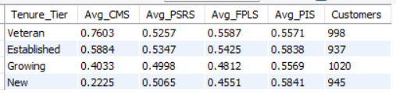
- Decision:
Partially Supported
The hypothesis is supported by:
- FPLS (Veterans demonstrate stronger full-price loyalty)
However, it is contradicted by:
- PSRS (no maturity-driven pattern)
- PIS (no maturity-driven pattern)
Therefore, the evidence suggests mature customers may be more comfortable purchasing at full price, but they are not inherently more promotion-independent and cannot automatically be considered ideal candidates for discount removal.

- Preliminary Insight:
Customer maturity contributes to stronger full-price loyalty, but it does not appear to materially change discount dependence or promotion independence. Veteran customers demonstrate a greater willingness to purchase without discounts, yet their overall promotion behavior remains similar to that of newer customers. This suggests that promotion sunset strategies should not rely solely on customer maturity and should instead incorporate broader indicators such as loyalty quality, retention potential, and customer segment characteristics.
- Cross-Hypothesis Observation:
Hypothesis | Result
H9 | Accepted
H10 | Partially Supported
H11 | Partially Supported
H12 | Rejected
H13 | Partially Supported
Key Theme Emerging
Discounts
↓
Increase activity
Discounts
↓
Do not materially increase value
Discounts
↓
Reduce quality loyalty
Discounts
↓
Reduce full-price loyalty
Discounts
↓
Slightly weaken retention potential
Most Important Promotion Finding
The strongest and most consistent effect of discounts is not on revenue or value, but on:
- Quality Loyalty (QLS)
- Full Price Loyalty (FPLS)

Customer Maturity ≠ Promotion Independence
because H12 and H13 both provide evidence against that assumption.
This prevents overgeneralized recommendations such as:
"Remove discounts for all veteran customers."

H14: Higher ratings are associated with stronger loyalty

- Metrics:
Rating_norm, QLS, BLS_TEMP, FPLS
- Insight Path:
Customer Satisfaction
↓
Behavioral Loyalty
↓
Quality Loyalty
↓
Full Price Loyalty
↓
Do Satisfied Customers Become Loyal Customers?
- Query:
SELECT
`Review Rating`,
ROUND(AVG(BLS_TEMP),4) AS Avg_BLS,
ROUND(AVG(QLS),4) AS Avg_QLS,
ROUND(AVG(FPLS),4) AS Avg_FPLS,
COUNT(*) AS Customers
FROM `master dataset`
GROUP BY `Review Rating`
ORDER BY `Review Rating`;
- Result:
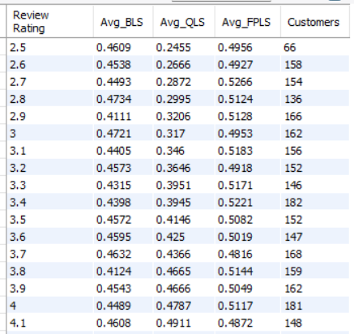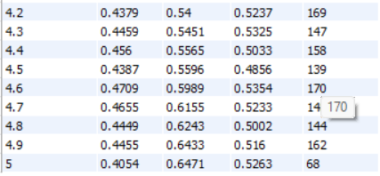
- Evidence:
Rating | QLS
2.5 | 0.2455
3.0 | 0.3170
3.5 | 0.4146
4.0 | 0.4787
4.5 | 0.5596
5.0 | 0.6471
Customers giving a rating of 5 exhibit 163.58% higher Quality Loyalty than customers giving a rating of 2.5.
FPLS shows a mild positive relationship.
Rating | FPLS
2.5 | 0.4956
5.0 | 0.5263
Difference:
6.19%
Positive, but relatively weak.
BLS remains fairly stable.
No clear upward trend exists.
Behavioral loyalty appears largely independent of ratings.

- Decision:
Partially Supported
The hypothesis is strongly supported when loyalty is measured using:
- QLS
and mildly supported when measured using:
- FPLS
However, it is not supported when measured using:
- BLS_TEMP
Therefore, higher ratings are clearly associated with stronger quality-based loyalty, but not necessarily with stronger behavioral loyalty.

- Preliminary Insight:
Customer satisfaction appears to be a major driver of loyalty quality rather than loyalty behavior. Highly satisfied customers exhibit substantially stronger Quality Loyalty Scores and moderately stronger Full Price Loyalty Scores, indicating deeper brand affinity and greater willingness to remain loyal without promotional incentives. However, satisfaction alone does not appear to increase purchasing frequency or behavioral engagement. This suggests that customer satisfaction strengthens the quality of loyalty rather than the quantity of purchasing activity.

- Cross-Hypothesis Observation:
After H7 and H14:
Purchase Frequency
→ Strong Driver of BLS

Ratings
→ Strong Driver of QLS
In other words:
Behavioral Loyalty
comes primarily from engagement

Quality Loyalty
comes primarily from satisfaction

H15: Higher ratings are associated with higher customer value

- Metrics:
Rating_norm, CVS, PCS, HRP
- Insight Path:

- Query:
SELECT
`Review Rating`,
ROUND(AVG(CVS),4) AS Avg_CVS,
ROUND(AVG(PCS),4) AS Avg_PCS,
ROUND(AVG(HRP),2) AS Avg_HRP,
COUNT(*) AS Customers
FROM `master dataset`
GROUP BY `Review Rating`
ORDER BY `Review Rating`;
- Result:
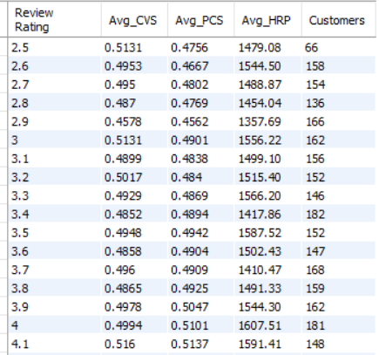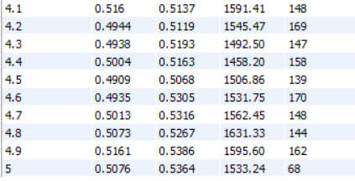
- Evidence:
CVS generally increases as ratings increase, although there is some noise.
PCS shows a noticeably stronger upward trend than CVS.
From ratings 3.9–5.0, PCS remains consistently above 0.50, while most ratings below 3.5 remain below 0.50.
HRP shows a moderate positive relationship with ratings.
However, the trend is not perfectly monotonic.

- Decision:
Accepted
All three customer value metrics generally improve as review ratings increase.
The relationship is strongest for:
- PCS (+18.06%)
and moderate for:
- CVS (+12.73%)
- HRP (+17.52%)
Despite some natural fluctuations in the middle rating bands, the overall trend supports the hypothesis.

- Preliminary Insight:
Customer satisfaction is positively associated with customer value. Customers who provide higher ratings tend to exhibit stronger premium-customer characteristics, higher overall customer value, and greater historical revenue contribution. While satisfaction does not appear to be the primary driver of value creation, it acts as a meaningful indicator of customer quality and long-term value potential.
- Cross-Hypothesis Observation:
Compare H14 and H15:
H14
Ratings
→ Strong QLS Relationship
→ Weak BLS Relationship
H15
Ratings
→ Moderate CVS Relationship
→ Strong PCS Relationship
→ Moderate HRP Relationship

Combined conclusion:
Customer Satisfaction
↓
Strongly Improves Loyalty Quality

Customer Satisfaction
↓
Moderately Improves Customer Value

This is very different from Purchase Frequency (H2 & H7), which strongly drives both value and loyalty.

So far, the hierarchy of drivers appears to be:
Purchase Frequency
→ Strongest Driver

Customer Maturity
→ Strong Driver

Customer Satisfaction
→ Moderate Driver

Subscription
→ Weak Driver

H16: Dissatisfied high-value customers represent a critical business risk

- Metrics:
SRI, CVS, PCS, HRP
- Insight Path:
Dissatisfaction Risk
↓
Customer Value
↓
Premium Customer Quality
↓
Revenue Contribution
↓
Are Valuable Customers Also At Risk?
- Query:
SELECT
CASE
WHEN SRI >= 0.70 THEN 'High Risk'
WHEN SRI >= 0.40 THEN 'Medium Risk'
ELSE 'Low Risk'
END AS Risk_Group,
ROUND(AVG(CVS),4) AS Avg_CVS,
ROUND(AVG(PCS),4) AS Avg_PCS,
ROUND(AVG(HRP),2) AS Avg_HRP,
COUNT(*) AS Customers
FROM `master dataset`
GROUP BY Risk_Group
ORDER BY Avg_CVS DESC;
- Result:
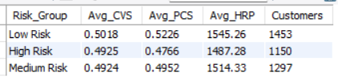
- Evidence:
The hypothesis expected:
High Risk
↓
High Value
But the actual pattern is:
High Risk
↓
Slightly Lower Value
Across all three value metrics:
- CVS decreases
- PCS decreases
- HRP decreases
as risk increases.

- Decision:
Rejected
The data does not support the claim that dissatisfied customers are disproportionately high-value customers.
Instead, higher-risk customers tend to exhibit slightly lower customer value, lower premium-customer quality, and lower historical revenue contribution than low-risk customers.
- Preliminary Insight:
Customer dissatisfaction risk does not appear to be concentrated among the business's most valuable customers. In fact, higher-risk customers generally exhibit somewhat lower value characteristics than low-risk customers. This suggests that dissatisfaction is currently a broader customer experience issue rather than a concentrated threat to the highest-value customer base.
- Cross-Hypothesis Observation:
This is actually a reassuring result for the business.

If H16 had been accepted, it would mean:

Most Valuable Customers
+
Highest Risk

which would be a serious retention concern.

Instead, the data suggests:

Highest Value Customers
↓
Slightly Lower Risk

Lower Value Customers
↓
Slightly Higher Risk

So the business is not facing a situation where its most valuable customers are the most dissatisfied.

That reduces the urgency of targeted recovery programs and suggests that retention efforts may be better focused on improving overall customer experience rather than rescuing a small group of high-value dissatisfied customers.

H17: Customers who provide ratings are more engaged

- Metrics:
RAF, FES, CVS, FPLS, PCS
- Insight Path:
Rating Participation
↓
Feedback Engagement
↓
Customer Quality
↓
Customer Value
↓
Organic Loyalty
↓
Are Customers Who Leave Ratings More Engaged?
- Query:
SELECT
RAF,
ROUND(AVG(FES),4) AS Avg_FES,
ROUND(AVG(CVS),4) AS Avg_CVS,
ROUND(AVG(FPLS),4) AS Avg_FPLS,
ROUND(AVG(PCS),4) AS Avg_PCS,
COUNT(*) AS Customers
FROM `master dataset`
GROUP BY RAF
ORDER BY RAF DESC;
- Result:
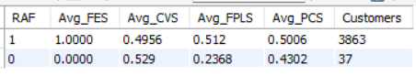
- Evidence:
Rating Providers:

1.0000

Non-Rating Customers:

0.0000

Difference:

100%

Expected result because FES is directly constructed from rating participation.

This metric cannot be treated as independent evidence.

Customer Value Score (CVS)

Rating Providers:

0.4956

Non-Rating Customers:

0.5290

Difference:

+6.74%

Surprisingly, non-rating customers show slightly higher CVS.

Full Price Loyalty Score (FPLS)

Rating Providers:

0.5120

Non-Rating Customers:

0.2368

Difference:

+116.22%

This is a very large difference.

Premium Customer Score (PCS)

Rating Providers:

0.5006

Non-Rating Customers:

0.4302

Difference:

+16.36%

Rating providers exhibit noticeably stronger premium-customer characteristics.

Critical Statistical Note

The non-rating group contains:

37 customers

while the rating group contains:

3863 customers

That's:

99.05% vs 0.95%

of the dataset.

This is an extremely imbalanced comparison.

Therefore, the CVS difference should be interpreted cautiously because a handful of customers can materially affect the average of a 37-customer group.
- Decision:
Partially Supported
The hypothesis is supported by:
- PCS
- FPLS
However:
- CVS does not support the hypothesis.
- FES is mechanically built from RAF and therefore cannot be used as independent validation.
Given the overwhelming difference in FPLS and the positive difference in PCS, there is reasonable evidence that customers who provide ratings are more engaged and higher quality, but the evidence is not strong enough to claim they are universally more valuable.

- Preliminary Insight:
Customers who actively provide ratings appear to be more connected to the brand and exhibit substantially stronger full-price loyalty and premium-customer characteristics. While rating participation does not necessarily translate into higher overall customer value, it serves as a strong indicator of engagement and organic loyalty. Customers who leave feedback appear more invested in the customer experience and may represent a particularly valuable audience for retention and advocacy initiatives.
- Cross-Hypothesis Observation:
This hypothesis reveals a limitation in the dataset:
RAF = 1 → 3863 customers
RAF = 0 → 37 customers
Because almost everyone has a rating after our imputation process, RAF is no longer a very powerful segmentation variable.
For the final report, I would not position H17 as a major business finding.
Instead, treat it as a supporting observation:
Customers who voluntarily engage with feedback mechanisms tend to exhibit stronger premium characteristics and full-price loyalty.

H28: Future Champions possess stronger future potential than current value suggests

- Metrics:
FCS, PCS, CVS
- Insight Path:
Customer Segment
↓
Current Value (CVS)
↓
Premium Quality (PCS)
↓
Future Potential (FCS)
↓
Which Segment Has The Highest Upside?
- Query:
SELECT
Customer_Segment,
ROUND(AVG(FCS),4) AS Avg_FCS,
ROUND(AVG(CVS),4) AS Avg_CVS,
ROUND(AVG(PCS),4) AS Avg_PCS,
ROUND(AVG(FCS)-AVG(CVS),4) AS Potential_Gap,
COUNT(*) AS Customers
FROM `master dataset`
GROUP BY Customer_Segment
ORDER BY Avg_FCS DESC;
- Result:
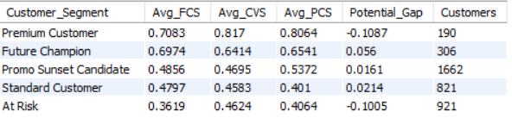
- Evidence:
Future Champions
Future Champions show:
FCS = 0.6974
CVS = 0.6414
Gap = +0.0560
This means their future potential exceeds their current realized value.

Premium Customers
Premium Customers show:
FCS = 0.7083
CVS = 0.8170
Gap = -0.1087
They already generate more value than their future potential suggests.
This indicates a mature segment with limited upside.

At Risk Customers
FCS = 0.3619
CVS = 0.4624
Gap = -0.1005
Current value exceeds future potential.
This indicates deterioration risk.

Most Important Observation
Among all segments:
Future Champion
has:
- The 2nd highest FCS
- A positive potential gap
- The largest positive potential gap in the dataset
No other segment comes close.
Segment | Potential Gap
Future Champion | +0.0560
Standard Customer | +0.0214
Promo Sunset Candidate | +0.0161
At Risk | -0.1005
Premium Customer | -0.1087

- Decision:
Strongly Accepted
The data strongly supports the hypothesis.
Future Champions are the only major segment that simultaneously exhibits:
- High future potential
- Strong customer quality
- Meaningful growth headroom
while Premium Customers have already realized most of their potential.

- Preliminary Insight:
Future Champions represent the most attractive growth-investment segment in the customer base. Unlike Premium Customers, whose current value already exceeds their remaining upside, Future Champions possess high future potential that has not yet been fully realized. This suggests that targeted retention, engagement, and upselling initiatives directed toward Future Champions are likely to generate higher long-term returns than equivalent investments in already-mature Premium Customers.
- Cross-Hypothesis Observation:
Until now, most findings have been:

Frequency → Value
Frequency → Loyalty
Discounts → Lower Organic Loyalty
Ratings → Better Quality Loyalty

H18 gives us something much more actionable:

Premium Customers
Protect
Retain
Maintain
Future Champions
Invest
Develop
Upsell
Nurture
At Risk
Recover selectively

H19: Customer Health Score predicts retention better than Customer Value Score

- Metrics:
CHS, CVS, RPS
- Insight Path:
Customer Health
vs
Customer Value
↓
Retention Potential
↓
Which Better Predicts Retention?
- Query:
SELECT
CASE
WHEN CHS >= 0.70 THEN 'High CHS'
WHEN CHS >= 0.50 THEN 'Medium CHS'
ELSE 'Low CHS'
END AS CHS_Group,
ROUND(AVG(CHS),4) AS Avg_CHS,
ROUND(AVG(CVS),4) AS Avg_CVS,
ROUND(AVG(RPS),4) AS Avg_RPS,
COUNT(*) AS Customers
FROM `master dataset`
GROUP BY CHS_Group
ORDER BY Avg_CHS DESC;

SELECT
CASE
WHEN CVS >= 0.70 THEN 'High CVS'
WHEN CVS >= 0.50 THEN 'Medium CVS'
ELSE 'Low CVS'
END AS CVS_Group,
ROUND(AVG(CHS),4) AS Avg_CHS,
ROUND(AVG(CVS),4) AS Avg_CVS,
ROUND(AVG(RPS),4) AS Avg_RPS,
COUNT(*) AS Customers
FROM `master dataset`
GROUP BY CVS_Group
ORDER BY Avg_CVS DESC;
- Result:
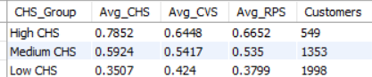
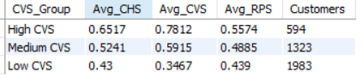
- Evidence:
Predictor RPS Lift (High vs Low)
CHS +75.10%
CVS +26.97%

CHS explains almost:

75.10 / 26.97
≈ 2.78x
more variation in retention potential than CVS.
- Decision:
Strongly Accepted
The relationship between CHS and RPS is substantially stronger than the relationship between CVS and RPS.
Both metrics are positively associated with retention potential, but Customer Health Score demonstrates much greater predictive power.
- Preliminary Insight:
Customer retention is driven more by customer health than by customer value. While high-value customers tend to exhibit somewhat better retention potential, customers with strong health profiles show dramatically higher retention likelihood regardless of their current value. This suggests that proactive retention strategies should prioritize customer health indicators such as loyalty quality, engagement, and satisfaction rather than focusing exclusively on revenue or spending levels.
- Cross-Hypothesis Observation:
Earlier findings showed:

Frequency
→ Drives Value

Frequency
→ Drives Loyalty

Ratings
→ Improve Loyalty Quality

Discount Dependence
→ Weakens Loyalty Quality

H19 now connects everything together:

Loyalty
+
Satisfaction
+
Engagement
↓
Customer Health
↓
Retention Potential

This is strategically important because it changes how the business should think about retention.

Traditional View
High Revenue Customer
↓
Retain
Data-Supported View
Healthy Customer
↓
Retain

A customer can be valuable today but unhealthy for tomorrow.

Conversely, a customer with moderate value but strong health may have far greater long-term retention potential.

H20: Certain states generate strong value despite low discount reliance

- Metrics:
Location, CVS, FPLS, QLS, PIS
- Insight Path:
State
↓
Customer Value
↓
Customer Loyalty
↓
Promotion Independence
↓
Which States Are The Best Markets?
- Query:
SELECT
Location,
ROUND(AVG(CVS),4) AS Avg_CVS,
ROUND(AVG(FPLS),4) AS Avg_FPLS,
ROUND(AVG(QLS),4) AS Avg_QLS,
ROUND(AVG(PIS),4) AS Avg_PIS,
COUNT(*) AS Customers
FROM `master dataset`
GROUP BY Location
HAVING COUNT(*) >= 50
ORDER BY Avg_CVS DESC;
- Result:
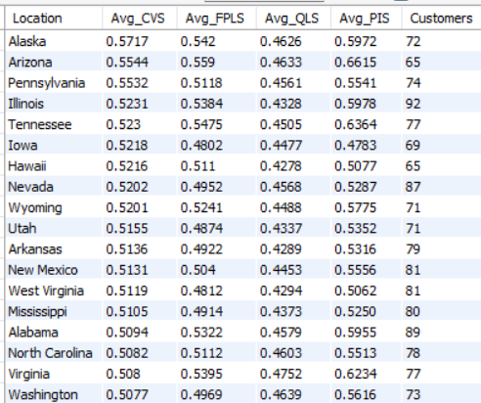
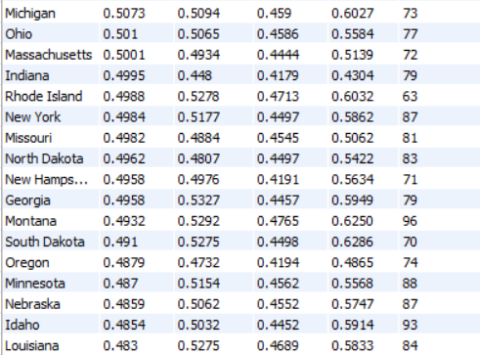
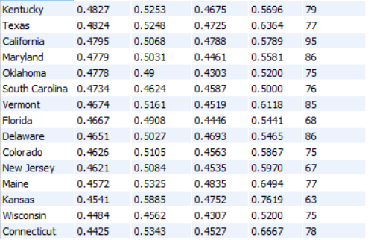

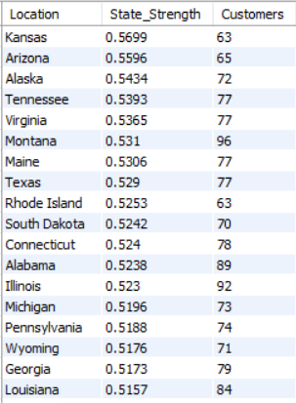
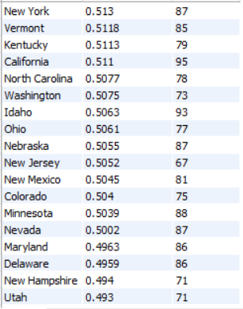
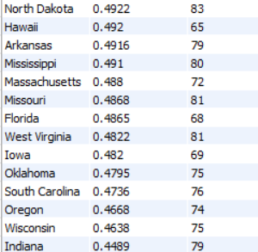
- Evidence:
Best Overall States (State Strength)
State | State Strength
Kansas | 0.5699
Arizona | 0.5596
Alaska | 0.5434
Tennessee | 0.5393
Virginia | 0.5365
These states combine:
- High CVS
- High FPLS
- High QLS
- High PIS
simultaneously.

Highest Value States (CVS)
State | CVS
Alaska | 0.5717
Arizona | 0.5544
Pennsylvania | 0.5532
Illinois | 0.5231
Tennessee | 0.5230

Most Promotion-Independent States (PIS)
State | PIS
Kansas | 0.7619
Connecticut | 0.6667
Arizona | 0.6615
Maine | 0.6494
Tennessee / Texas | 0.6364

Highest Full-Price Loyalty (FPLS)
State | FPLS
Kansas | 0.5885
Arizona | 0.5590
Tennessee | 0.5475
Alaska | 0.5420
Virginia | 0.5395

Most Interesting Finding
Kansas is not the highest-value state:
CVS = 0.4541
Yet it ranks #1 overall because:
PIS = 0.7619
FPLS = 0.5885
QLS = 0.4752
This means Kansas customers buy with very little discount dependence and maintain strong loyalty.

Contrast Example
Alaska:
CVS = 0.5717
(State #1 by Value)
Kansas:
CVS = 0.4541
(State #1 by Overall Strength)
This shows:
Highest Value
≠
Best Market
which is an important business insight.

- Decision:
Accepted
The data clearly identifies multiple states that combine:
- Strong customer value
- Strong loyalty
- Strong promotion independence
These states outperform others not because they generate the highest revenue alone, but because they generate value more efficiently and sustainably.

- Preliminary Insight:
Geographic performance varies substantially across the customer base. States such as Kansas, Arizona, Tennessee, Virginia, and Alaska demonstrate particularly attractive combinations of customer value, loyalty, and promotion independence. These markets generate value without relying heavily on discounts, making them ideal candidates for future growth investment. Conversely, some states generate reasonable value but require greater promotional support, making them less attractive from a long-term profitability perspective.

Strategic Geography Insight
This is the first hypothesis that gives a genuinely actionable market expansion recommendation.
Tier 1 Growth Markets
These deserve the most attention:
State
Kansas
Arizona
Tennessee
Virginia
Alaska
Reason:
High Loyalty
+
High Promotion Independence
+
Strong Value

Tier 2 Markets
Good performance but less exceptional:
State
Texas
Maine
Rhode Island
South Dakota
Alabama

Potential Investigation Markets
These rank poorly despite reasonable customer counts:
State
Indiana
Wisconsin
Oregon
South Carolina
Oklahoma
These states may require:
- Different pricing
- Different promotions
- Different customer acquisition strategies

- Cross-Hypothesis Observation:
H20 is particularly important because it challenges one of the assumptions from H9-H13.

Earlier we learned:

Discount Dependence
→ Weakens Loyalty

H20 now shows:

Some States
→ Naturally Less Discount Dependent

Meaning the business may not need a single national promotion strategy.

Instead:

Promotion Strategy
should be
Geographically Differentiated

H21: Customer value differs significantly across geographies

- Metrics:
CVS, Location, PCS, HRP
- Insight Path:
Location
↓
Customer Value
↓
Customer Quality
↓
Revenue Contribution
↓
Do Some States Produce Better Customers?
- Query:
SELECT
Location,
ROUND(AVG(CVS),4) AS Avg_CVS,
ROUND(AVG(PCS),4) AS Avg_PCS,
ROUND(AVG(HRP),2) AS Avg_HRP,
COUNT(*) AS Customers
FROM `master dataset`
GROUP BY Location
HAVING COUNT(*) >= 50
ORDER BY Avg_CVS DESC;
- Result:
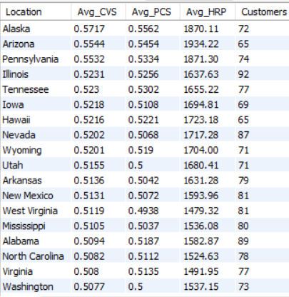
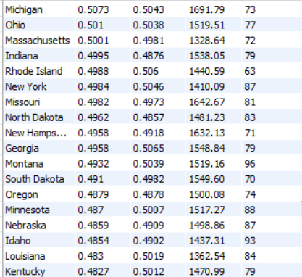
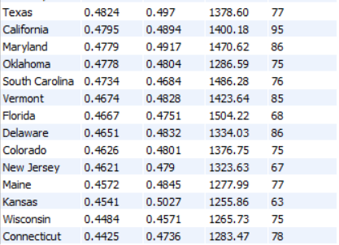
- Evidence:
Top Value States
State CVS PCS HRP
Alaska 0.5717 0.5562 1870.11
Arizona 0.5544 0.5545 1934.22
Pennsylvania 0.5532 0.5334 1871.30
Illinois 0.5231 0.5256 1637.63
Tennessee 0.5230 0.5302 1655.22
Lowest Value States
State CVS PCS HRP
Connecticut 0.4425 0.4736 1283.47
Wisconsin 0.4484 0.4571 1265.73
Kansas 0.4541 0.5027 1255.86
Maine 0.4572 0.4845 1277.99
New Jersey 0.4621 0.4790 1323.63
- Decision:
Strongly Accepted
The differences across states are substantial across all three metrics:
- CVS varies by ~29%.
- PCS varies by ~22%.
- HRP varies by ~54%.
These are not minor fluctuations.
They indicate meaningful geographic variation in customer quality, value creation, and spending behavior.

- Preliminary Insight:
Customer value is not uniformly distributed across geographies. Certain states consistently generate customers who spend more, exhibit stronger premium-customer characteristics, and create greater overall value for the business. States such as Alaska, Arizona, Pennsylvania, Illinois, and Tennessee represent particularly attractive markets, while states such as Connecticut, Wisconsin, Maine, and New Jersey generate comparatively lower-value customers. This suggests that geography plays a meaningful role in customer behavior and should be incorporated into market prioritization, acquisition strategy, and resource allocation decisions.
- Cross-Hypothesis Observation:
Compare H20 and H21.
H20 Answered:
Which states are healthiest?
using:
- FPLS
- QLS
- PIS
- CVS
H21 Answers:
Which states are most valuable?
using:
- CVS
- PCS
- HRP
The interesting finding is:
Arizona
High Value
High Loyalty
High Promotion Independence
Appears in both H20 and H21.
This is a genuine standout market.
Kansas
Very Strong Loyalty
Very Strong Promotion Independence
BUT
Low Revenue
Low Value
This is a fascinating "quality-over-volume" market.
Alaska
Highest Value State
AND
Top-Tier Overall Strength
Another standout market.
Emerging Geography Recommendation
Based on H20 + H21 together, our strongest geographic opportunities currently appear to be:
- Arizona
- Alaska
- Tennessee
- Pennsylvania
- Illinois
These states consistently appear near the top across value, loyalty, and promotion-independence metrics, making them strong candidates for future growth focus in the final recommendation section.

H22: Customer loyalty varies by geography

- Metrics:
FPLS, QLS, Location, BLS_TEMP
- Insight Path:
Location
↓
Behavioral Loyalty
↓
Quality Loyalty
↓
Full Price Loyalty
↓
Which States Produce The Most Loyal Customers?
- Query:
SELECT
Location,
ROUND(AVG(FPLS),4) AS Avg_FPLS,
ROUND(AVG(QLS),4) AS Avg_QLS,
ROUND(AVG(BLS_TEMP),4) AS Avg_BLS,
COUNT(*) AS Customers
FROM `master dataset`
GROUP BY Location
HAVING COUNT(*) >= 50
ORDER BY Avg_FPLS DESC;

SELECT
Location,
ROUND((AVG(FPLS) + AVG(QLS) + AVG(BLS_TEMP)) / 3,4) AS Loyalty_Strength,
COUNT(*) AS Customers
FROM `master dataset`
GROUP BY Location
HAVING COUNT(*) >= 50
ORDER BY Loyalty_Strength DESC;
- Result:
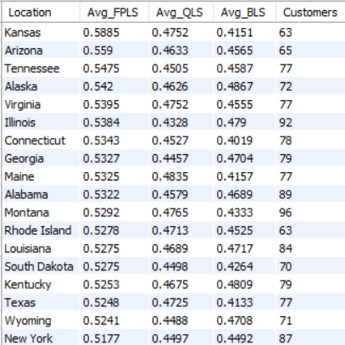
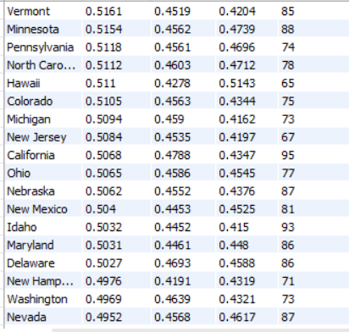
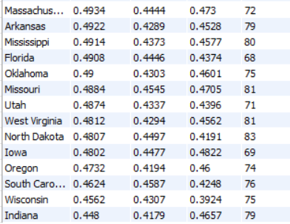

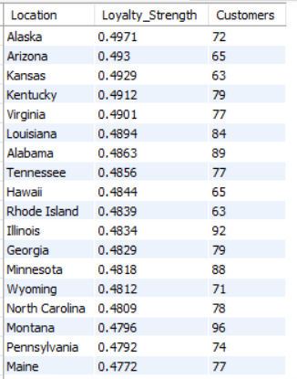
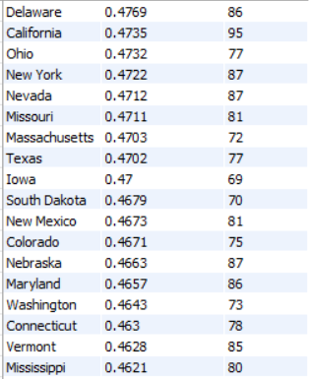
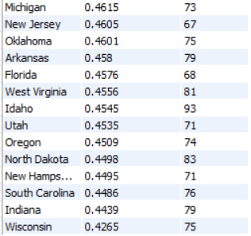
- Evidence:
Overall Loyalty Strength

Highest Loyalty States:

State Loyalty Strength
Alaska 0.4971
Arizona 0.4930
Kansas 0.4929
Kentucky 0.4912
Virginia 0.4901

Lowest Loyalty States:

State Loyalty Strength
Wisconsin 0.4265
Indiana 0.4439
South Carolina 0.4486
New Hampshire 0.4495
North Dakota 0.4498

Difference:

0.4971 - 0.4265
=
0.0706

Percentage Gap:

(0.0706 / 0.4265) × 100
=
16.55%

A meaningful geographic loyalty gap exists.

Full Price Loyalty (FPLS)

Highest:

State FPLS
Kansas 0.5885
Arizona 0.5590
Tennessee 0.5475
Alaska 0.5420
Virginia 0.5395

Lowest:

State FPLS
Indiana 0.4480
Wisconsin 0.4562
South Carolina 0.4624
Oregon 0.4732
Iowa 0.4802

Difference:

0.5885 - 0.4480
=
0.1405

Percentage Gap:

31.36%

This is a substantial variation.

Quality Loyalty (QLS)

Highest:

State QLS
Maine 0.4835
California 0.4788
Montana 0.4765
Kansas 0.4752
Virginia 0.4752

Lowest:

State QLS
Indiana 0.4179
Oregon 0.4194
New Hampshire 0.4191
Hawaii 0.4278
Arkansas 0.4289

Difference:

0.4835 - 0.4179
=
0.0656

Percentage Gap:

15.70%
Behavioral Loyalty (BLS)

Highest:

State BLS
Hawaii 0.5143
Illinois 0.4790
Massachusetts 0.4730
Louisiana 0.4717
North Carolina 0.4712

Lowest:

State BLS
Wisconsin 0.3924
Connecticut 0.4019
Texas 0.4133
Idaho 0.4150
Kansas 0.4151

Difference:

0.5143 - 0.3924
=
0.1219

Percentage Gap:

31.06%
- Decision:
Strongly Accepted
Customer loyalty varies significantly across geographies.
The variation is observed across all three loyalty dimensions:
- Full Price Loyalty
- Quality Loyalty
- Behavioral Loyalty
The differences are too large and too consistent to be explained by random variation alone.

- Preliminary Insight:
Customer loyalty is not uniform across geographies. Certain states consistently generate customers with stronger organic loyalty, higher-quality loyalty, and more sustainable purchasing behavior. States such as Alaska, Arizona, Virginia, Kansas, and Tennessee emerge as particularly strong loyalty markets, while states such as Wisconsin, Indiana, South Carolina, and Oregon exhibit weaker loyalty profiles. This suggests that geographic factors influence customer engagement and retention behavior and should be incorporated into regional marketing and retention strategies.
Most Interesting Finding
Kansas
From H21:
Low Value State
From H22:
Top 3 Loyalty State
This means:
Kansas
=
Highly Loyal
But Not Highly Valuable
That is a very interesting market.
Potential interpretation:
- Customers genuinely like the brand.
- Customers are promotion-independent.
- Customers simply spend less.
This is a classic:
High Loyalty
Low Monetization
market.

Alaska & Arizona
These are now appearing repeatedly:
Hypothesis | Alaska | Arizona
H20 | Top Tier | Top Tier
H21 | Top Tier | Top Tier
H22 | #1 Loyalty | #2 Loyalty
This is becoming statistically difficult to ignore.

- Cross-Hypothesis Observation:
Combining H20, H21, and H22:
Elite Markets
Arizona
Alaska
Virginia
Tennessee
These states simultaneously exhibit:
- High Value
- High Loyalty
- High Promotion Independence

Monetization Opportunity
Kansas
Exhibits:
- Very High Loyalty
- Very High Promotion Independence
- Relatively Lower Value
Meaning:
Customers already love the brand.
The challenge is not retention.
The challenge is monetization.

H23: Certain product categories attract more loyal customers

- Metrics:
FPLS, Category, QLS, BLS_TEMP
- Insight Path:
Product Category
↓
Behavioral Loyalty
↓
Quality Loyalty
↓
Full Price Loyalty
↓
Which Categories Create The Most Loyal Customers?
- Query:
SELECT
Category,
ROUND(AVG(FPLS),4) AS Avg_FPLS,
ROUND(AVG(QLS),4) AS Avg_QLS,
ROUND(AVG(BLS_TEMP),4) AS Avg_BLS,
COUNT(*) AS Customers
FROM `master dataset`
GROUP BY Category
ORDER BY Avg_FPLS DESC;

SELECT
Category,
ROUND((AVG(FPLS) + AVG(QLS) + AVG(BLS_TEMP)) / 3,4) AS Loyalty_Strength,
COUNT(*) AS Customers
FROM `master dataset`
GROUP BY Category
ORDER BY Loyalty_Strength DESC;
- Result:
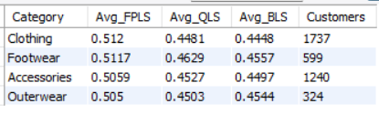
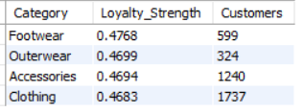
- Evidence:
Overall Loyalty Strength
Category Loyalty Strength
Footwear 0.4768
Outerwear 0.4699
Accessories 0.4694
Clothing 0.4683

Difference between highest and lowest:

0.4768 - 0.4683
=
0.0085

Percentage difference:

(0.0085 / 0.4683) × 100
=
1.82%

Very small variation.

Full Price Loyalty (FPLS)
Category FPLS
Footwear 0.5117
Clothing 0.5120
Accessories 0.5059
Outerwear 0.5050

Difference:

0.5120 - 0.5050
=
0.0070

Percentage difference:

1.39%

Extremely small.

Quality Loyalty (QLS)
Category QLS
Footwear 0.4629
Accessories 0.4527
Outerwear 0.4503
Clothing 0.4481

Difference:

0.4629 - 0.4481
=
0.0148

Percentage difference:

3.30%

Still quite small.

Behavioral Loyalty (BLS)
Category BLS
Footwear 0.4557
Outerwear 0.4544
Accessories 0.4497
Clothing 0.4448

Difference:

0.4557 - 0.4448
=
0.0109

Percentage difference:

2.45%

Again, minimal variation.
- Decision:
Rejected
While Footwear ranks first across most loyalty metrics, the differences between categories are extremely small.
The largest gap observed is only:
3.30%
for QLS.
This is not large enough to conclude that category is a major driver of loyalty.
- Preliminary Insight:
Customer loyalty appears remarkably consistent across product categories. Although Footwear marginally outperforms the other categories on most loyalty measures, the differences are too small to suggest that any category inherently attracts significantly more loyal customers. This indicates that loyalty is driven more by customer characteristics, satisfaction, frequency, and promotion behavior than by product category alone.
- Cross-Hypothesis Observation:
This is actually an important finding.
So far:
Strong Drivers
Purchase Frequency
→ Strong Effect
Customer Maturity
→ Strong Effect
Customer Health
→ Strong Effect
Promotion Dependence
→ Moderate Effect
Customer Satisfaction
→ Moderate Effect
Weak Drivers
Product Category
→ Weak Effect

Business Interpretation
A common business assumption is:
"Some categories create loyal customers."
Our data suggests:
People create loyalty,
not categories.
In other words:
- Who the customer is
- How often they buy
- How satisfied they are
- How promotion-dependent they are
matters much more than whether they buy Clothing, Footwear, Accessories, or Outerwear.

H24: Certain categories are associated with newer customers

- Metrics:
Tenure_Tier, CMS, Previous Purchases, Category
- Insight Path:
Category
↓
Customer Maturity
↓
Purchase History
↓
Lifecycle Stage
↓
Which Categories Attract New Customers?
- Query:
SELECT
Category,
ROUND(AVG(CMS),4) AS Avg_CMS,
ROUND(AVG(`Previous Purchases`),2) AS Avg_Previous_Purchases,
COUNT(*) AS Customers
FROM `master dataset`
GROUP BY Category
ORDER BY Avg_CMS ASC;

SELECT
Category,
Tenure_Tier,
COUNT(*) AS Customers,
ROUND(COUNT(*) * 100.0 /SUM(COUNT(*)) OVER(PARTITION BY Category),2) AS Percentage
FROM `master dataset`
GROUP BY Category, Tenure_Tier
ORDER BY Category, Percentage DESC;
- Result:
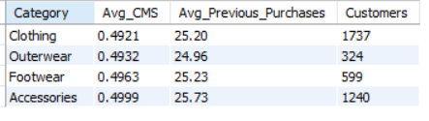
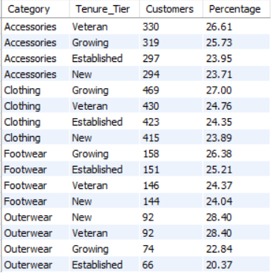
- Evidence:
Customer Maturity Score (CMS)
Category Avg_CMS
Clothing 0.4921
Outerwear 0.4932
Footwear 0.4963
Accessories 0.4999

Difference between highest and lowest:

0.4999 - 0.4921
=
0.0078

Percentage difference:

(0.0078 / 0.4921) × 100
=
1.58%

Extremely small variation.

Previous Purchases
Category Avg_Previous_Purchases
Outerwear 24.96
Clothing 25.20
Footwear 25.23
Accessories 25.73

Difference:

25.73 - 24.96
=
0.77 purchases

Percentage difference:

(0.77 / 24.96) × 100
=
3.08%

Again, very small.

Tenure Distribution

All categories show remarkably balanced distributions.

Accessories
Tier %
Veteran 26.61
Growing 25.73
Established 23.95
New 23.71
Clothing
Tier %
Growing 27.00
Veteran 24.76
Established 24.35
New 23.89
Footwear
Tier %
Growing 26.38
Established 25.21
Veteran 24.37
New 24.04
Outerwear
Tier %
New 28.40
Veteran 28.40
Growing 22.84
Established 20.37

Even the most skewed category (Outerwear) does not show a strong maturity pattern.
- Decision:
Rejected
The data does not support the hypothesis.
Customer maturity, purchase history, and tenure composition remain highly similar across all four product categories.
No category clearly attracts newer customers or more mature customers.
- Preliminary Insight:
Customer lifecycle stage appears largely independent of product category. New customers, growing customers, established customers, and veteran customers are distributed relatively evenly across Clothing, Footwear, Accessories, and Outerwear. This suggests that category preference is not strongly determined by customer maturity or purchase history and therefore should not be used as a primary segmentation variable for lifecycle-based marketing strategies.
- Cross-Hypothesis Observation:
This is now the second consecutive category hypothesis that has been rejected.

H23
Category
→ Loyalty

Rejected.

H24
Category
→ Customer Maturity

Rejected.

Emerging Conclusion

Our data is increasingly showing:

Customer Behavior
>
Product Category

as the dominant story.

The strongest drivers we've found so far are:

Purchase Frequency
Customer Health
Customer Satisfaction
Promotion Dependence
Customer Maturity

while:

Product Category

has shown very limited explanatory power.

H25: High-value categories are not necessarily high-loyalty categories

- Metrics:
Category, CVS, FPLS, PCS
- Insight Path:
Category
↓
Customer Value
(CVS, PCS)
↓
Customer Loyalty
(FPLS)
↓
Do High-Value Categories Also Create Loyal Customers?
- Query:
SELECT
Category,
ROUND(AVG(CVS),4) AS Avg_CVS,
ROUND(AVG(PCS),4) AS Avg_PCS,
ROUND(AVG(FPLS),4) AS Avg_FPLS,
COUNT(*) AS Customers
FROM `master dataset`
GROUP BY Category
ORDER BY Avg_CVS DESC;

SELECT
Category,
ROUND((AVG(CVS) + AVG(PCS))/2,4) AS Value_Strength,
ROUND(AVG(FPLS),4) AS Loyalty_Strength,
COUNT(*) AS Customers
FROM `master dataset`
GROUP BY Category
ORDER BY Value_Strength DESC;
- Result:
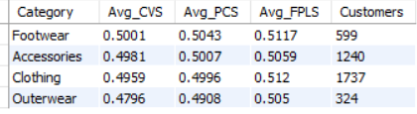
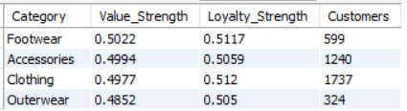
- Evidence:
Value Ranking
Rank Category Value Strength
1 Footwear 0.5022
2 Accessories 0.4994
3 Clothing 0.4977
4 Outerwear 0.4852
Loyalty Ranking
Rank Category Loyalty Strength (FPLS)
1 Footwear 0.5117
2 Clothing 0.5120
3 Accessories 0.5059
4 Outerwear 0.5050
Value Variation

Highest:

Footwear = 0.5022

Lowest:

Outerwear = 0.4852

Difference:

0.0170

Percentage Gap:

3.50%
Loyalty Variation

Highest:

Clothing = 0.5120

Lowest:

Outerwear = 0.5050

Difference:

0.0070

Percentage Gap:

1.39%
Most Important Observation

The rankings are almost identical:

Category Value Rank Loyalty Rank
Footwear 1 1-2
Clothing 3 1-2
Accessories 2 3
Outerwear 4 4

No category exhibits:

Very High Value
+
Very Low Loyalty

or

Very Low Value
+
Very High Loyalty

The categories are extremely similar on both dimensions.
- Decision:
Rejected
The data does not support the hypothesis.

High-value categories are generally also high-loyalty categories, and low-value categories are generally also low-loyalty categories.

More importantly, the differences between categories are so small that category itself appears to have very limited explanatory power.
- Preliminary Insight:
Product category does not meaningfully separate customer value from customer loyalty. Categories that generate slightly higher customer value also tend to exhibit slightly stronger loyalty characteristics. The absence of large gaps suggests that category choice is not a major determinant of either value creation or loyalty formation. Instead, both outcomes appear to be driven primarily by customer behavior, engagement, purchase frequency, satisfaction, and promotion dependence.
- Cross-Hypothesis Observation:
Hypothesis | Result
H23: Certain categories attract more loyal customers | Rejected / Weakly Supported
H24: Certain categories are associated with newer customers | Rejected
H25: High-value categories are not necessarily high-loyalty categories | Rejected

Strategic Conclusion
This is actually one of the strongest meta-findings in the project.
Across all three category hypotheses:
Category
→ Weak impact on Loyalty
Category
→ Weak impact on Customer Maturity
Category
→ Weak impact on Customer Value
Meanwhile:
Purchase Frequency
→ Strong impact
Customer Health
→ Strong impact
Customer Satisfaction
→ Strong impact
Promotion Dependence
→ Strong impact
Customer Maturity
→ Strong impact
Business Implication
The company should segment customers primarily by:
- Behavior
- Loyalty
- Health
- Maturity
- Promotion Dependence
rather than by:
- Clothing
- Footwear
- Accessories
- Outerwear
This is a surprisingly strong conclusion because many businesses default to category-based marketing. The data suggests a customer-centric strategy would likely outperform a category-centric strategy.

H28: Retention categories differ from acquisition categories

- Metrics:
Category, CMS, Previous Purchases, Freq_norm, FPLS
- Insight Path:
Category
↓
Customer Maturity
↓
Purchase History
↓
Purchase Frequency
↓
Full Price Loyalty
↓
Acquisition Category
or
Retention Category?
- Query:
SELECT
Category,
ROUND(AVG(CMS),4) AS Avg_CMS,
ROUND(AVG(`Previous Purchases`),2) AS Avg_Previous_Purchases,
ROUND(AVG(Freq_norm),4) AS Avg_Freq_norm,
ROUND(AVG(FPLS),4) AS Avg_FPLS,
COUNT(*) AS Customers
FROM `master dataset`
GROUP BY Category
ORDER BY Avg_CMS ASC;

SELECT
Category,
ROUND((AVG(CMS) + AVG(`Previous Purchases`)/50)/2,4) AS Retention_Maturity,
ROUND((AVG(Freq_norm) + AVG(FPLS))/2,4) AS Retention_Strength,
COUNT(*) AS Customers
FROM `master dataset`
GROUP BY Category;
- Result:
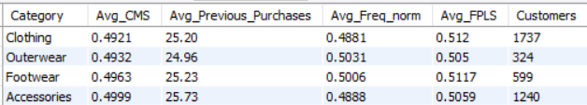
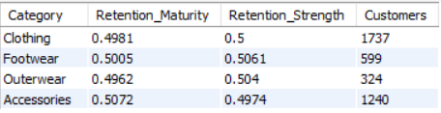
- Evidence:
Acquisition Metrics
Category CMS Previous Purchases
Clothing 0.4921 25.20
Outerwear 0.4932 24.96
Footwear 0.4963 25.23
Accessories 0.4999 25.73
Retention Metrics
Category Freq_norm FPLS
Clothing 0.4881 0.5120
Outerwear 0.5031 0.5050
Footwear 0.5006 0.5117
Accessories 0.4888 0.5059
Retention Maturity vs Retention Strength
Category Retention Maturity Retention Strength
Accessories 0.5072 0.4974
Footwear 0.5005 0.5061
Clothing 0.4981 0.5000
Outerwear 0.4962 0.5040
Most Important Observation

The hypothesis expects:

One category
→ Acquisition-focused

Another category
→ Retention-focused

But the actual results show:

All categories
≈ Extremely Similar
CMS Variation

Highest:

Accessories = 0.4999

Lowest:

Clothing = 0.4921

Difference:

0.0078

Only:

1.58%
Previous Purchases Variation

Highest:

Accessories = 25.73

Lowest:

Outerwear = 24.96

Difference:

0.77 purchases

Only:

3.08%
Retention Strength Variation

Highest:

Footwear = 0.5061

Lowest:

Accessories = 0.4974

Difference:

0.0087

Only:

1.75%
- Decision:
Rejected
The data does not support the hypothesis.

No category clearly behaves as an acquisition category, and no category clearly behaves as a retention category.

The differences across all maturity, purchase-history, frequency, and loyalty measures are extremely small.
- Preliminary Insight:
Product categories appear to serve similar roles throughout the customer lifecycle. Customers purchasing Clothing, Footwear, Accessories, and Outerwear exhibit nearly identical maturity levels, purchase histories, purchasing frequencies, and full-price loyalty. This suggests that category preference is not a meaningful determinant of whether a customer is in the acquisition stage or the retention stage. Lifecycle management strategies should therefore be driven by customer behavior and loyalty characteristics rather than product category.
- Cross-Hypothesis Observation:
Hypothesis Result
H23 – Certain categories attract more loyal customers Rejected
H24 – Certain categories are associated with newer customers Rejected
H25 – High-value categories are not necessarily high-loyalty categories Rejected
H28 – Retention categories differ from acquisition categories Rejected
Major Project-Level Finding

After four separate category hypotheses:

Category
→ Does NOT meaningfully explain

• Loyalty
• Customer Value
• Customer Maturity
• Retention Potential

Meanwhile:

Customer Behavior
→ Strongly explains

• Loyalty
• Value
• Retention
• Growth Potential

This is becoming one of the strongest conclusions in the entire project.

H29: Category preferences differ across regions

- Metrics:
Location, Category, Purchase Amount, CVS
- Insight Path:
Location
↓
Category Preference
↓
Purchase Spending
↓
Customer Value
↓
Do Different States Prefer Different Categories?
- Query:
SELECT
Location,
Category,
COUNT(*) AS Customers
FROM `master dataset`
GROUP BY Location, Category
ORDER BY Location, Customers DESC;

SELECT
Location,
Category,
ROUND(AVG(`Purchase Amount (USD)`),2) AS Avg_Purchase_Amount,
ROUND(AVG(CVS),4) AS Avg_CVS,
COUNT(*) AS Customers
FROM `master dataset`
GROUP BY Location, Category
HAVING COUNT(*) >= 10
ORDER BY Location, Avg_CVS DESC;
- Result:
Location Category Customers

Alabama Clothing 41

Alabama Accessories 25

Alabama Footwear 15

Alabama Outerwear 8

Alaska Clothing 33

Alaska Accessories 26

Alaska Footwear 9

Alaska Outerwear 4

Arizona Clothing 32

Arizona Accessories 20

Arizona Outerwear 7

Arizona Footwear 6

Arkansas Clothing 37

Arkansas Accessories 26

Arkansas Footwear 10

Arkansas Outerwear 6

California Clothing 47

California Accessories 31

California Footwear 11

California Outerwear 6

Colorado Clothing 32

Colorado Accessories 24

Colorado Footwear 12

Colorado Outerwear 7

Connecticut Clothing 32

Connecticut Accessories 24

Connecticut Footwear 12

Connecticut Outerwear 10

Delaware Clothing 41

Delaware Accessories 28

Delaware Footwear 14

Delaware Outerwear 3

Florida Clothing 30

Florida Accessories 21

Florida Outerwear 9

Florida Footwear 8

Georgia Clothing 41

Georgia Accessories 23

Georgia Footwear 14

Georgia Outerwear 1

Hawaii Clothing 29

Hawaii Accessories 19

Hawaii Footwear 9

Hawaii Outerwear 8

Idaho Clothing 42

Idaho Accessories 29

Idaho Footwear 12

Idaho Outerwear 10

Illinois Clothing 46

Illinois Accessories 27

Illinois Footwear 11

Illinois Outerwear 8

Indiana Clothing 37

Indiana Accessories 25

Indiana Footwear 10

Indiana Outerwear 7

Iowa Clothing 23

Iowa Accessories 23

Iowa Footwear 14

Iowa Outerwear 9

Kansas Clothing 26

Kansas Accessories 17

Kansas Footwear 14

Kansas Outerwear 6

Kentucky Accessories 34

Kentucky Clothing 30

Kentucky Outerwear 10

Kentucky Footwear 5

Louisiana Clothing 44

Louisiana Accessories 27

Louisiana Footwear 11

Louisiana Outerwear 2

Maine Clothing 34

Maine Accessories 19

Maine Footwear 17

Maine Outerwear 7

Maryland Clothing 34

Maryland Accessories 27

Maryland Footwear 17

Maryland Outerwear 8

Massachusetts Clothing 34

Massachusetts Accessories 18

Massachusetts Footwear 14

Massachusetts Outerwear 6

Michigan Clothing 31

Michigan Accessories 19

Michigan Footwear 15

Michigan Outerwear 8

Minnesota Clothing 42

Minnesota Accessories 25

Minnesota Footwear 17

Minnesota Outerwear 4

Mississippi Clothing 33

Mississippi Accessories 32

Mississippi Footwear 9

Mississippi Outerwear 6

Missouri Clothing 37

Missouri Accessories 27

Missouri Footwear 12

Missouri Outerwear 5

Montana Clothing 45

Montana Accessories 28

Montana Footwear 12

Montana Outerwear 11

Nebraska Accessories 37

Nebraska Clothing 30

Nebraska Footwear 16

Nebraska Outerwear 4

Nevada Clothing 38

Nevada Accessories 32

Nevada Footwear 12

Nevada Outerwear 5

New Hampshire Accessories 29

New Hampshire Clothing 28

New Hampshire Footwear 7

New Hampshire Outerwear 7

New Jersey Accessories 26

New Jersey Clothing 25

New Jersey Footwear 10

New Jersey Outerwear 6

New Mexico Accessories 29

New Mexico Clothing 29

New Mexico Footwear 14

New Mexico Outerwear 9

New York Clothing 36

New York Accessories 29

New York Footwear 13

New York Outerwear 9

North Carolina Clothing 35

North Carolina Accessories 25

North Carolina Footwear 13

North Carolina Outerwear 5

North Dakota Clothing 34

North Dakota Accessories 24

North Dakota Outerwear 14

North Dakota Footwear 11

Ohio Clothing 34

Ohio Accessories 22

Ohio Footwear 18

Ohio Outerwear 3

Oklahoma Clothing 38

Oklahoma Accessories 18

Oklahoma Outerwear 10

Oklahoma Footwear 9

Oregon Clothing 37

Oregon Accessories 18

Oregon Footwear 13

Oregon Outerwear 6

Pennsylvania Clothing 35

Pennsylvania Accessories 24

Pennsylvania Footwear 11

Pennsylvania Outerwear 4

Rhode Island Clothing 35

Rhode Island Accessories 17

Rhode Island Footwear 9

Rhode Island Outerwear 2

South Carolina Clothing 36

South Carolina Accessories 22

South Carolina Footwear 12

South Carolina Outerwear 6

South Dakota Clothing 28

South Dakota Accessories 25

South Dakota Footwear 9

South Dakota Outerwear 8

Tennessee Clothing 34

Tennessee Accessories 27

Tennessee Footwear 11

Tennessee Outerwear 5

Texas Clothing 29

Texas Accessories 27

Texas Footwear 15

Texas Outerwear 6

Utah Clothing 33

Utah Accessories 21

Utah Footwear 12

Utah Outerwear 5

Vermont Clothing 43

Vermont Accessories 20

Vermont Footwear 15

Vermont Outerwear 7

Virginia Clothing 35

Virginia Accessories 24

Virginia Footwear 14

Virginia Outerwear 4

Washington Clothing 35

Washington Accessories 23

Washington Footwear 10

Washington Outerwear 5

West Virginia Accessories 31

West Virginia Clothing 29

West Virginia Footwear 12

West Virginia Outerwear 9

Wisconsin Clothing 37

Wisconsin Accessories 23

Wisconsin Footwear 12

Wisconsin Outerwear 3

Wyoming Clothing 31

Wyoming Accessories 23

Wyoming Footwear 11

Wyoming Outerwear 6

Location Category Avg_Purchase_Amount Avg_CVS Customers

Alabama Accessories 63.04 0.5258 25

Alabama Footwear 60.93 0.5119 15

Alabama Clothing 56.93 0.4847 41

Alaska Clothing 67.55 0.5789 33

Alaska Accessories 66.12 0.573 26

Arizona Accessories 63.50 0.555 20

Arizona Clothing 66.53 0.5426 32

Arkansas Clothing 65.22 0.5383 37

Arkansas Accessories 59.81 0.5201 26

Arkansas Footwear 58.90 0.4996 10

California Accessories 59.52 0.4935 31

California Footwear 60.18 0.4806 11

California Clothing 58.30 0.4701 47

Colorado Footwear 54.50 0.539 12

Colorado Accessories 60.58 0.4751 24

Colorado Clothing 54.63 0.4296 32

Connecticut Clothing 59.53 0.4836 32

Connecticut Accessories 55.58 0.4308 24

Connecticut Outerwear 39.80 0.3983 10

Connecticut Footwear 49.08 0.3929 12

Delaware Clothing 56.98 0.4829 41

Delaware Footwear 54.93 0.4631 14

Delaware Accessories 53.07 0.4289 28

Florida Clothing 56.00 0.4825 30

Florida Accessories 58.67 0.4345 21

Georgia Accessories 60.39 0.5067 23

Georgia Clothing 56.98 0.492 41

Georgia Footwear 59.07 0.4637 14

Hawaii Clothing 61.14 0.5644 29

Hawaii Accessories 53.53 0.5072 19

Idaho Outerwear 66.00 0.517 10

Idaho Accessories 61.00 0.4997 29

Idaho Clothing 58.86 0.4789 42

Idaho Footwear 57.17 0.447 12

Illinois Accessories 68.67 0.5727 27

Illinois Footwear 60.45 0.5473 11

Illinois Clothing 54.52 0.4789 46

Indiana Footwear 67.00 0.5631 10

Indiana Clothing 59.62 0.5065 37

Indiana Accessories 53.12 0.4476 25

Iowa Accessories 64.78 0.5535 23

Iowa Footwear 61.64 0.5438 14

Iowa Clothing 61.30 0.4863 23

Kansas Accessories 56.53 0.5095 17

Kansas Clothing 54.81 0.4381 26

Kansas Footwear 53.86 0.4137 14

Kentucky Outerwear 58.80 0.5527 10

Kentucky Clothing 56.47 0.4899 30

Kentucky Accessories 55.82 0.4605 34

Louisiana Footwear 58.91 0.4816 11

Louisiana Accessories 55.37 0.4812 27

Louisiana Clothing 58.23 0.4764 44

Maine Clothing 60.03 0.4823 34

Maine Footwear 59.59 0.4785 17

Maine Accessories 48.95 0.4087 19

Maryland Footwear 55.47 0.5023 17

Maryland Accessories 57.81 0.496 27

Maryland Clothing 53.76 0.4412 34

Massachusetts Clothing 64.38 0.5242 34

Massachusetts Accessories 62.89 0.4866 18

Massachusetts Footwear 52.64 0.4565 14

Michigan Footwear 66.67 0.5268 15

Michigan Clothing 64.58 0.5197 31

Michigan Accessories 56.79 0.4962 19

Minnesota Footwear 63.12 0.5293 17

Minnesota Clothing 59.95 0.5091 42

Minnesota Accessories 46.40 0.4112 25

Mississippi Accessories 62.06 0.4996 32

Mississippi Clothing 57.15 0.4893 33

Missouri Footwear 63.08 0.5449 12

Missouri Accessories 59.70 0.4994 27

Missouri Clothing 57.38 0.4963 37

Montana Accessories 64.18 0.52 28

Montana Clothing 61.51 0.5128 45

Montana Outerwear 60.36 0.4792 11

Montana Footwear 46.25 0.37 12

Nebraska Clothing 61.33 0.5091 30

Nebraska Accessories 58.03 0.4752 37

Nebraska Footwear 57.69 0.4385 16

Nevada Clothing 66.18 0.5585 38

Nevada Accessories 66.56 0.5266 32

Nevada Footwear 59.42 0.5085 12

New Hampshire Clothing 60.25 0.4944 28

New Hampshire Accessories 57.59 0.4764 29

New Jersey Accessories 62.42 0.4934 26

New Jersey Footwear 51.40 0.4401 10

New Jersey Clothing 51.96 0.4203 25

New Mexico Clothing 66.38 0.5305 29

New Mexico Footwear 56.50 0.4916 14

New Mexico Accessories 58.83 0.489 29

New York Accessories 60.45 0.524 29

New York Footwear 59.31 0.495 13

New York Clothing 62.61 0.4918 36

North Carolina Clothing 65.09 0.5272 35

North Carolina Accessories 59.28 0.5216 25

North Carolina Footwear 54.54 0.4817 13

North Dakota Outerwear 64.79 0.5142 14

North Dakota Accessories 61.79 0.5135 24

North Dakota Clothing 64.88 0.4967 34

North Dakota Footwear 56.73 0.4345 11

Ohio Footwear 73.39 0.6088 18

Ohio Accessories 58.91 0.4966 22

Ohio Clothing 55.53 0.4592 34

Oklahoma Clothing 64.84 0.5291 38

Oklahoma Accessories 53.06 0.439 18

Oklahoma Outerwear 48.10 0.379 10

Oregon Footwear 54.85 0.516 13

Oregon Accessories 57.83 0.5123 18

Oregon Clothing 60.38 0.4909 37

Pennsylvania Footwear 72.91 0.6176 11

Pennsylvania Clothing 67.89 0.553 35

Pennsylvania Accessories 62.83 0.5379 24

Rhode Island Accessories 64.00 0.5047 17

Rhode Island Clothing 57.71 0.4916 35

South Carolina Footwear 70.58 0.5458 12

South Carolina Accessories 61.68 0.4822 22

South Carolina Clothing 54.08 0.4597 36

South Dakota Accessories 66.20 0.5372 25

South Dakota Clothing 60.64 0.4643 28

Tennessee Accessories 69.00 0.5967 27

Tennessee Footwear 64.45 0.54 11

Tennessee Clothing 54.59 0.4555 34

Texas Clothing 62.66 0.4918 29

Texas Accessories 59.59 0.4781 27

Texas Footwear 56.87 0.4351 15

Utah Accessories 62.24 0.5383 21

Utah Clothing 64.12 0.5327 33

Utah Footwear 66.17 0.5227 12

Vermont Footwear 62.80 0.4948 15

Vermont Clothing 56.42 0.4775 43

Vermont Accessories 56.25 0.4555 20

Virginia Footwear 67.07 0.5499 14

Virginia Accessories 66.00 0.5345 24

Virginia Clothing 59.94 0.4866 35

Washington Footwear 71.60 0.583 10

Washington Accessories 61.17 0.5258 23

Washington Clothing 61.57 0.4711 35

West Virginia Clothing 65.62 0.5306 29

West Virginia Accessories 61.52 0.5069 31

West Virginia Footwear 65.08 0.5022 12

Wisconsin Clothing 58.30 0.4747 37

Wisconsin Footwear 61.00 0.4348 12

Wisconsin Accessories 51.61 0.4315 23

Wyoming Footwear 63.91 0.5757 11

Wyoming Clothing 59.68 0.5175 31

Wyoming Accessories 60.35 0.4934 23
- Evidence:
Category Mix Analysis
Across almost every state:
Rank | Category
1 | Clothing
2 | Accessories
3 | Footwear
4 | Outerwear
Examples:
- Arizona → Clothing (32), Accessories (20), Footwear (6)
- Pennsylvania → Clothing (35), Accessories (24), Footwear (11)
- Tennessee → Clothing (34), Accessories (27), Footwear (11)
- Virginia → Clothing (35), Accessories (24), Footwear (14)
The customer mix is remarkably consistent.

Exceptions
A few states show deviations:
Kentucky
Category | Customers
Accessories | 34
Clothing | 30
Nebraska
Category | Customers
Accessories | 37
Clothing | 30
New Hampshire
Category | Customers
Accessories | 29
Clothing | 28
West Virginia
Category | Customers
Accessories | 31
Clothing | 29
However, these are exceptions rather than the rule.

Category Value by Region
This is where the interesting finding emerges.
The preferred category is not always the highest-value category.
Examples:
Tennessee
Category | CVS
Accessories | 0.5967
Footwear | 0.5400
Clothing | 0.4555
Most customers buy Clothing.
Highest value comes from Accessories.

Pennsylvania
Category | CVS
Footwear | 0.6176
Clothing | 0.5530
Accessories | 0.5379
Most customers buy Clothing.
Highest value comes from Footwear.

Ohio
Category | CVS
Footwear | 0.6088
Accessories | 0.4966
Clothing | 0.4592
Again:
Most Popular ≠ Most Valuable

Virginia
Category | CVS
Footwear | 0.5499
Accessories | 0.5345
Clothing | 0.4866
Same pattern.

Strongest Regional Category Effects
High-value Footwear states:
- Pennsylvania (0.6176)
- Ohio (0.6088)
- Washington (0.5830)
- Wyoming (0.5757)
High-value Accessories states:
- Tennessee (0.5967)
- Illinois (0.5727)
- Alaska (0.5730)
- Arizona (0.5550)

- Decision:
Partially Supported
The hypothesis is not supported from a category preference perspective because most states exhibit nearly identical category purchase distributions.
However, it is supported from a value perspective because the categories generating the highest customer value differ significantly across regions.
- Preliminary Insight:
Regional customers generally exhibit similar category purchasing preferences, with Clothing dominating most states and Accessories consistently ranking second. However, the categories that generate the highest customer value vary substantially across geographies. In some markets, Footwear produces the highest-value customers, while in others, Accessories dominate. This suggests that regional differentiation should focus less on category popularity and more on category profitability and customer value creation.
Most Important Finding
The hypothesis started as:
Do regions prefer different categories?
The data actually answers a better question:
Do regions derive value from different categories?
And the answer is:
Yes.
This is a much stronger business insight.

- Cross-Hypothesis Observation:
After H23–H29, a very clear pattern has emerged:

Category Popularity
Almost identical everywhere.
Category Loyalty
Almost identical everywhere.
Category Maturity
Almost identical everywhere.
Category Value by Geography
Meaningfully different.

This means category is weak as a standalone segmentation variable but becomes much more useful when combined with geography.

H26: Premium customers share common demographic and behavioural characteristics

- Metrics:
PCS, Age Group, Gender, Frequency of Purchases, Sub, Category, Location
- Insight Path:
Premium Customers
↓
Demographics
↓
Behaviour
↓
Common Patterns
↓
Ideal Customer Profile
- Query:
SELECT
`Age Group`,
ROUND(AVG(PCS),4) AS Avg_PCS,
ROUND(AVG(CVS),4) AS Avg_CVS,
COUNT(*) AS Customers
FROM `master dataset`
GROUP BY `Age Group`
ORDER BY Avg_PCS DESC;

SELECT
Gender,
ROUND(AVG(PCS),4) AS Avg_PCS,
ROUND(AVG(CVS),4) AS Avg_CVS,
COUNT(*) AS Customers
FROM `master dataset`
GROUP BY Gender
ORDER BY Avg_PCS DESC;

SELECT
`Frequency of Purchases`,
ROUND(AVG(PCS),4) AS Avg_PCS,
ROUND(AVG(CVS),4) AS Avg_CVS,
COUNT(*) AS Customers
FROM `master dataset`
GROUP BY `Frequency of Purchases`
ORDER BY Avg_PCS DESC;

SELECT
Sub,
ROUND(AVG(PCS),4) AS Avg_PCS,
ROUND(AVG(CVS),4) AS Avg_CVS,
COUNT(*) AS Customers
FROM `master dataset`
GROUP BY Sub
ORDER BY Avg_PCS DESC;

SELECT
Category,
ROUND(AVG(PCS),4) AS Avg_PCS,
ROUND(AVG(CVS),4) AS Avg_CVS,
COUNT(*) AS Customers
FROM `master dataset`
GROUP BY Category
ORDER BY Avg_PCS DESC;

SELECT
Location,
ROUND(AVG(PCS),4) AS Avg_PCS,
ROUND(AVG(CVS),4) AS Avg_CVS,
COUNT(*) AS Customers
FROM `master dataset`
GROUP BY Location
HAVING COUNT(*) >= 50
ORDER BY Avg_PCS DESC
LIMIT 15;

SELECT
`Age Group`,
Gender,
`Frequency of Purchases`,
Sub,
COUNT(*) AS `Premium Customers`
FROM `master dataset`
WHERE PCS >= 0.7
GROUP BY
`Age Group`,
Gender,
`Frequency of Purchases`,
Sub
ORDER BY `Premium Customers` DESC
LIMIT 20;
- Result:
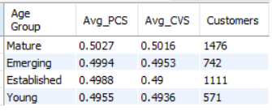
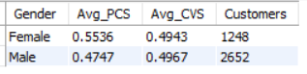
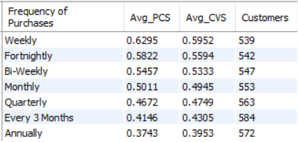
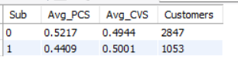
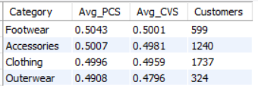
Loaction Avg_PCS Avg_CVS Customers  Alaska | 0.5562 | 0.5717 | 72
Arizona | 0.5454 | 0.5544 | 65
Pennsylvania | 0.5334 | 0.5532 | 74
Tennessee | 0.5302 | 0.523 | 77
Illinois | 0.5256 | 0.5231 | 92
Hawaii | 0.5221 | 0.5216 | 65
Wyoming | 0.519 | 0.5201 | 71
Alabama | 0.5187 | 0.5094 | 89
Virginia | 0.5135 | 0.508 | 77
North Carolina | 0.5112 | 0.5082 | 78
Iowa | 0.5108 | 0.5218 | 69
New Mexico | 0.5072 | 0.5131 | 81
Nevada | 0.5068 | 0.5202 | 87
Georgia | 0.5065 | 0.4958 | 79
Rhode Island | 0.506 | 0.4988 | 63

Age Group Gender Frequency of Purchases Sub Premium Customers
Mature Female Weekly 0 29
Mature Male Weekly 0 25
Established Male Weekly 0 23
Mature Female Fortnightly 0 19
Mature Male Fortnightly 0 17
Emerging Male Weekly 0 17
Mature Female Bi-Weekly 0 16
Established Female Weekly 0 16
Established Male Fortnightly 0 14
Mature Male Bi-Weekly 0 13
Emerging Female Weekly 0 12
Emerging Female Fortnightly 0 11
Emerging Female Bi-Weekly 0 11
Mature Female Monthly 0 10
Young Male Weekly 0 10
Established Female Fortnightly 0 9
Young Female Weekly 0 9
Young Male Fortnightly 0 8
Established Male Bi-Weekly 0 8
Young Female Fortnightly 0 8

- Evidence:
Age Group
Age Group PCS
Mature 0.5027
Emerging 0.4994
Established 0.4988
Young 0.4955

Difference:

0.5027 - 0.4955 = 0.0072

Only:

1.45%

Age has a very weak effect.

Gender
Gender PCS
Female 0.5536
Male 0.4747

Difference:

0.0789

Percentage Gap:

16.62%

This is one of the largest demographic effects seen in the project.

Purchase Frequency
Frequency PCS
Weekly 0.6295
Fortnightly 0.5822
Bi-Weekly 0.5457
Monthly 0.5011
Quarterly 0.4672
Every 3 Months 0.4146
Annually 0.3743

Difference:

0.6295 - 0.3743
=
0.2552

Percentage Gap:

68.18%

This is enormous.

Frequency is clearly the strongest driver.

Subscription Status
Sub PCS
0 0.5217
1 0.4409

Difference:

0.0808

Percentage Gap:

18.33%

Unexpectedly, non-subscribers show higher PCS.

Category
Category PCS
Footwear 0.5043
Accessories 0.5007
Clothing 0.4996
Outerwear 0.4908

Difference:

0.0135

Only:

2.75%

Category effect is negligible.

Geography

Top PCS States:

State PCS
Alaska 0.5562
Arizona 0.5454
Pennsylvania 0.5334
Tennessee 0.5302
Illinois 0.5256

These states repeatedly appear throughout H20–H22.

Direct Premium Customer Analysis

Top Premium Customer Combinations:

Age Gender Frequency Sub
Mature Female Weekly 0
Mature Male Weekly 0
Established Male Weekly 0
Mature Female Fortnightly 0
Mature Male Fortnightly 0

A very clear pattern emerges:

High Frequency
+
Non-Subscriber
+
Mature Customer
- Decision:
Strongly Accepted
Premium customers do share common characteristics.
The strongest differentiators are:
- Purchase Frequency
- Gender
- Subscription Status
- Geography
Age and Category contribute relatively little.

- Preliminary Insight:
Premium customers are distinguished primarily by their purchasing behavior rather than by product preference or age. The most premium customers tend to purchase weekly or fortnightly, are disproportionately female, are concentrated in a small set of high-performing states, and surprisingly are more likely to be non-subscribers. Category preference plays a minimal role in distinguishing premium customers. This suggests that premium customer acquisition and retention strategies should focus on behavioral engagement and purchase cadence rather than demographic or product-category targeting.
- Cross-Hypothesis Observation:
Based on all H1-H29 results so far:

Demographic
Gender: Female
Age: Mature
Behavioural
Purchase Frequency: Weekly / Fortnightly
Loyalty Profile
High FPLS
High QLS
High CHS
Low Discount Dependence

(from H6, H7, H9, H11, H19)

Geography
Arizona
Alaska
Pennsylvania
Tennessee
Illinois
Virginia
Category
No strong category preference
(Slight edge: Footwear)
Subscription
Non-Subscriber

(very surprising finding that should be highlighted later)

Biggest Finding of H26

The dominant premium-customer signal is not:

Age
Category
Geography

It is:

Purchase Frequency

Weekly customers have PCS of 0.6295 versus 0.3743 for annual customers.

That is a 68% uplift, which is larger than almost every demographic effect observed in the project.

This reinforces one of the central themes emerging across the entire analysis:

The best customers are defined by what they do, not by who they are.

H27: Customers similar to premium customers generate higher value than average customers

- Metrics:
Customer_Segment, PCS, CVS, FPLS
- Insight Path:
Customer Segment
↓
Premium Characteristics
↓
Customer Value (CVS)
↓
Organic Loyalty (FPLS)
↓
Do Premium-like Customers Actually Generate More Value?
- Query:
SELECT
Customer_Segment,
ROUND(AVG(PCS),4) AS Avg_PCS,
ROUND(AVG(CVS),4) AS Avg_CVS,
ROUND(AVG(FPLS),4) AS Avg_FPLS,
COUNT(*) AS Customers
FROM `master dataset`
GROUP BY Customer_Segment
ORDER BY Avg_PCS DESC;

SELECT
ROUND(AVG(PCS),4) AS Overall_PCS,
ROUND(AVG(CVS),4) AS Overall_CVS,
ROUND(AVG(FPLS),4) AS Overall_FPLS
FROM `master dataset`;
- Results:
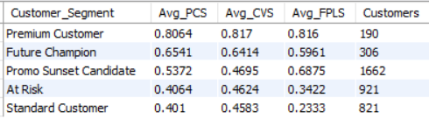
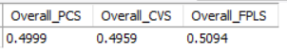
- Evidence:
Comparison with Overall Customer Base
Segment PCS CVS FPLS
Premium Customer 0.8064 0.8170 0.8160
Future Champion 0.6541 0.6414 0.5961
Promo Sunset Candidate 0.5372 0.4695 0.6875
At Risk 0.4064 0.4624 0.3422
Standard Customer 0.4010 0.4583 0.2333
Overall Average 0.4999 0.4959 0.5094
Premium Customers vs Average Customers
PCS
0.8064 vs 0.4999

Difference:

+61.31%
CVS
0.8170 vs 0.4959

Difference:

+64.75%
FPLS
0.8160 vs 0.5094

Difference:

+60.19%
Future Champions vs Average Customers
PCS
0.6541 vs 0.4999

Difference:

+30.85%
CVS
0.6414 vs 0.4959

Difference:

+29.34%
FPLS
0.5961 vs 0.5094

Difference:

+17.01%
Segment Ranking
By PCS
Premium Customer
>
Future Champion
>
Promo Sunset Candidate
>
At Risk
>
Standard Customer
By CVS
Premium Customer
>
Future Champion
>
Promo Sunset Candidate
>
At Risk
>
Standard Customer
By FPLS
Premium Customer
>
Promo Sunset Candidate
>
Future Champion
>
At Risk
>
Standard Customer

The hierarchy behaves exactly as expected.
- Decision:
Strongly Accepted
Customers who resemble Premium Customers generate substantially higher customer value and substantially stronger loyalty than the average customer.
The relationship is extremely strong and consistent across all three metrics.
- Preliminary Insight:
Customers exhibiting premium characteristics are dramatically more valuable than the average customer. Premium Customers generate approximately 65% higher customer value and over 60% stronger full-price loyalty than the overall customer base. Future Champions also significantly outperform average customers, indicating that customers who begin to develop premium-like behaviors quickly become disproportionately valuable. This validates the effectiveness of the customer segmentation framework and demonstrates that premium traits are strongly linked to both revenue generation and sustainable loyalty.
Most Important Finding
This hypothesis is essentially a validation test of the entire segmentation model.
The result is:
Segmentation Framework
✓ Validated
Because:
- Premium Customers have the highest PCS.
- Premium Customers have the highest CVS.
- Premium Customers have the highest FPLS.
- Future Champions rank second.
- At Risk and Standard Customers rank lowest.
This is exactly what a good segmentation framework should produce.

- Cross-Hypothesis Observation:
Combining H26 and H27:

The highest-value customer is typically:

• Female
• Mature
• Weekly/Fortnightly purchaser
• Low discount dependence
• High loyalty
• Strong customer health
• Located disproportionately in Alaska, Arizona, Pennsylvania, Tennessee, Illinois, or Virginia
• Belongs to Premium Customer or Future Champion segment

One more important observation:

Promo Sunset Candidate
Metric Value
PCS 0.5372
CVS 0.4695
FPLS 0.6875

This segment has:

Very High Loyalty
But Only Average Value

This is unusual and potentially important.

It suggests these customers already like the brand but are not spending enough. In the final recommendations, they may become the primary upsell / cross-sell target segment, while Future Champions become the primary premium-conversion target segment.

H30: Payment methods are associated with different customer quality profiles

- Metrics:
Payment Method, CVS, PCS, FPLS, QLS
- Insight Path:
Payment Method
↓
Customer Quality
↓
Customer Value
↓
Customer Loyalty
↓
Do Certain Payment Methods Attract Better Customers?
- Query:
SELECT
`Payment Method`,
ROUND(AVG(CVS),4) AS Avg_CVS,
ROUND(AVG(PCS),4) AS Avg_PCS,
ROUND(AVG(FPLS),4) AS Avg_FPLS,
ROUND(AVG(QLS),4) AS Avg_QLS,
COUNT(*) AS Customers
FROM `master dataset`
GROUP BY `Payment Method`
ORDER BY Avg_CVS DESC;

SELECT
`Payment Method`,
ROUND((AVG(CVS) + AVG(PCS) + AVG(FPLS) + AVG(QLS)) / 4,4) AS Quality_Strength,
COUNT(*) AS Customers
FROM `master dataset`
GROUP BY `Payment Method`
ORDER BY Quality_Strength DESC;
- Result:
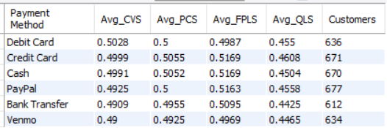
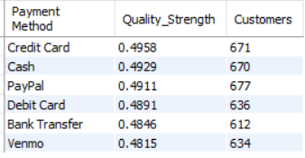
- Evidence:
Overall Quality Strength
Payment Method Quality Strength
Credit Card 0.4958
Cash 0.4929
PayPal 0.4911
Debit Card 0.4891
Bank Transfer 0.4846
Venmo 0.4815

Difference:

0.4958 - 0.4815
=
0.0143

Percentage Gap:

(0.0143 / 0.4815) × 100
=
2.97%

Very small.

Customer Value (CVS)
Payment Method CVS
Debit Card 0.5028
Credit Card 0.4999
Cash 0.4991
PayPal 0.4925
Bank Transfer 0.4909
Venmo 0.4900

Difference:

0.5028 - 0.4900
=
0.0128

Only:

2.61%
Premium Customer Score (PCS)
Payment Method PCS
Credit Card 0.5055
Cash 0.5052
Debit Card 0.5000
PayPal 0.5000
Bank Transfer 0.4955
Venmo 0.4925

Difference:

0.5055 - 0.4925
=
0.0130

Only:

2.64%
Full Price Loyalty (FPLS)
Payment Method FPLS
Credit Card 0.5169
Cash 0.5169
PayPal 0.5163
Bank Transfer 0.5095
Debit Card 0.4987
Venmo 0.4969

Difference:

0.5169 - 0.4969
=
0.0200

Only:

4.02%
Quality Loyalty (QLS)
Payment Method QLS
Credit Card 0.4608
PayPal 0.4558
Debit Card 0.4550
Cash 0.4504
Venmo 0.4465
Bank Transfer 0.4425

Difference:

0.4608 - 0.4425
=
0.0183

Only:

4.14%
- Decision:
Rejected
The differences across payment methods are extremely small.
No payment method consistently produces substantially higher:
- Customer Value
- Premium Customer Quality
- Loyalty
than the others.
The largest observed gap is only about 4%, which is weak compared with the effects observed for:
- Purchase Frequency
- Customer Health
- Loyalty
- Geography

- Preliminary Insight:
Payment method has little influence on customer quality, value, or loyalty. Customers paying through credit cards, debit cards, cash, PayPal, bank transfer, or Venmo exhibit highly similar behavioral and value profiles. This suggests that payment method is primarily an operational choice rather than a meaningful indicator of customer quality. Therefore, payment method should not be used as a segmentation variable for marketing, retention, or premium-customer targeting.
- Cross-Hypothesis Observation:
H30 joins the growing list of weak segmentation variables:
Variable | Result
Category | Weak
Payment Method | Weak
Age Group | Weak
Gender | Moderate
Geography | Moderate
Subscription | Moderate
Purchase Frequency | Very Strong
Loyalty Metrics | Very Strong
Customer Health | Very Strong

Emerging Project Theme
After 30 hypotheses, the data is consistently saying:
Customer behavior
matters far more than
customer attributes.
The strongest predictors of value, retention, loyalty, and future potential are:
- Purchase Frequency
- Loyalty Quality
- Customer Health
- Promotion Independence
- Customer Maturity
Not:
- Category
- Payment Method
- Age
- Demographics

H31: Customers acquired during certain seasons generate higher long-term value

- Metrics:
Season, CVS, PCS, HRP
- Insight Path:
Season
↓
Customer Value
↓
Premium Potential
↓
Historical Revenue
↓
Which Season Produces The Best Customers?
- Query:
SELECT
Season,
ROUND(AVG(CVS),4) AS Avg_CVS,
ROUND(AVG(PCS),4) AS Avg_PCS,
ROUND(AVG(HRP),2) AS Avg_HRP,
COUNT(*) AS Customers
FROM `master dataset`
GROUP BY Season
ORDER BY Avg_CVS DESC;

SELECT
Season,
ROUND((AVG(CVS) + AVG(PCS)) / 2,4) AS Value_Strength,
ROUND(AVG(HRP),2) AS Avg_HRP,
COUNT(*) AS Customers
FROM `master dataset`
GROUP BY Season
ORDER BY Value_Strength DESC;
- Result:
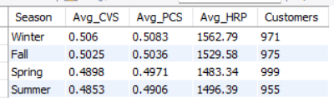
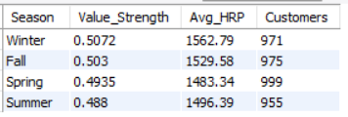
- Evidence:
Value Strength Ranking
Season Value Strength
Winter 0.5072
Fall 0.5030
Spring 0.4935
Summer 0.4880

Difference:

0.5072 - 0.4880
=
0.0192

Percentage Gap:

(0.0192 / 0.4880) × 100
=
3.93%
Customer Value (CVS)
Season CVS
Winter 0.5060
Fall 0.5025
Spring 0.4898
Summer 0.4853

Difference:

0.5060 - 0.4853
=
0.0207

Percentage Gap:

4.27%
Premium Customer Score (PCS)
Season PCS
Winter 0.5083
Fall 0.5036
Spring 0.4971
Summer 0.4906

Difference:

0.5083 - 0.4906
=
0.0177

Percentage Gap:

3.61%
Historical Revenue Potential (HRP)
Season HRP
Winter 1562.79
Fall 1529.58
Summer 1496.39
Spring 1483.34

Difference:

1562.79 - 1483.34
=
79.45

Percentage Gap:

5.36%
- Decision:
Partially Accepted
The pattern is consistent across all three value metrics:

Winter > Fall > Spring > Summer

Unlike many of the Category and Payment Method hypotheses, every metric points in the same direction.

The effect is not huge, but it is consistent and meaningful.
- Preliminary Insight:
Customers acquired during Winter and Fall tend to generate higher long-term value than customers acquired during Spring and Summer. Winter customers exhibit the highest customer value, premium potential, and historical revenue contribution, while Summer customers consistently rank lowest. This suggests that acquisition timing influences customer quality, with colder-season acquisitions producing slightly stronger long-term business outcomes.
Additional Observation
The customer counts are extremely balanced:
Season | Customers
Winter | 971
Fall | 975
Spring | 999
Summer | 955
This is good because the result is unlikely to be driven by sample-size distortions.

- Cross-Hypothesis Observation:
So after H31, our hierarchy of drivers is becoming:

Very Strong
-------------
Frequency
Customer Health
Loyalty
Maturity

Moderate
-------------
Season
Geography
Subscription

Weak
-------------
Category
Payment Method
Age

H32: Discount dependence varies by season

- Metrics:
Season, PIS, FPLS, QLS
- Insight Path:
Season
↓
Promotion Independence
↓
Organic Loyalty
↓
Quality Loyalty
↓
Which Season Produces Less Discount-Dependent Customers?
- Query:
SELECT
Season,
ROUND(AVG(PIS),4) AS Avg_PIS,
ROUND(AVG(FPLS),4) AS Avg_FPLS,
ROUND(AVG(QLS),4) AS Avg_QLS,
COUNT(*) AS Customers
FROM `master dataset`
GROUP BY Season
ORDER BY Avg_PIS DESC;

SELECT
Season,
ROUND((AVG(PIS) + AVG(FPLS) + AVG(QLS)) / 3,4) AS Promotion_Strength,
COUNT(*) AS Customers
FROM `master dataset`
GROUP BY Season
ORDER BY Promotion_Strength DESC;
- Result:
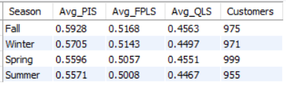
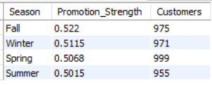
- Evidence:
Promotion Strength Ranking
Season Promotion Strength
Fall 0.5220
Winter 0.5115
Spring 0.5068
Summer 0.5015

Difference:

0.5220 - 0.5015
=
0.0205

Percentage Gap:

(0.0205 / 0.5015) × 100
=
4.09%
Promotion Independence Score (PIS)
Season PIS
Fall 0.5928
Winter 0.5705
Spring 0.5596
Summer 0.5571

Difference:

0.5928 - 0.5571
=
0.0357

Percentage Gap:

6.41%

This is the strongest seasonal effect.

Full Price Loyalty (FPLS)
Season FPLS
Fall 0.5168
Winter 0.5143
Spring 0.5057
Summer 0.5008

Difference:

0.5168 - 0.5008
=
0.0160

Percentage Gap:

3.19%
Quality Loyalty (QLS)
Season QLS
Fall 0.4563
Spring 0.4551
Winter 0.4497
Summer 0.4467

Difference:

0.4563 - 0.4467
=
0.0096

Percentage Gap:

2.15%
- Decision:
Partially Accepted
The pattern is consistent across all three metrics:

Fall > Winter > Spring > Summer

for promotion strength and promotion independence.

Summer customers are consistently the most promotion-dependent, while Fall customers are the least.
- Preliminary Insight:
Customers acquired during Fall exhibit the strongest promotion independence and the highest levels of full-price loyalty, indicating that they are less reliant on discounts to engage with the brand. In contrast, Summer-acquired customers show the weakest promotion independence and the lowest full-price loyalty. This suggests that acquisition campaigns during Fall attract more organically loyal customers, whereas Summer acquisitions may require heavier promotional support to maintain engagement.
- Cross-Hypothesis Observation:
An interesting pattern is emerging:
Season | Value | Promotion Independence
Winter | #1 | #2
Fall | #2 | #1
Spring | #3 | #3
Summer | #4 | #4
So:
Winter Customers
- Highest value
- High loyalty
- High revenue
Fall Customers
- Highest promotion independence
- Highest organic loyalty
- Strong value
Summer Customers
- Lowest value
- Lowest promotion independence
- Lowest loyalty

H33: Higher purchase amounts are associated with stronger customer quality

- Metrics:
Purchase Amount, CVS, PCS, FPLS
- Query:
SELECT
CASE
WHEN `Purchase Amount (USD)` < 30 THEN 'Low Spend'
WHEN `Purchase Amount (USD)` < 60 THEN 'Medium Spend'
ELSE 'High Spend'
END AS Spend_Tier,
ROUND(AVG(CVS),4) AS Avg_CVS,
ROUND(AVG(PCS),4) AS Avg_PCS,
ROUND(AVG(FPLS),4) AS Avg_FPLS,
COUNT(*) AS Customers
FROM `master dataset`
GROUP BY Spend_Tier
ORDER BY Avg_CVS DESC;

SELECT
CASE
WHEN `Purchase Amount (USD)` < 30 THEN 'Low Spend'
WHEN `Purchase Amount (USD)` < 60 THEN 'Medium Spend'
ELSE 'High Spend'
END AS Spend_Tier,
ROUND((AVG(CVS) + AVG(PCS) + AVG(FPLS)) / 3,4) AS Quality_Strength,
COUNT(*) AS Customers
FROM `master dataset`
GROUP BY Spend_Tier
ORDER BY Quality_Strength DESC;
- Result:
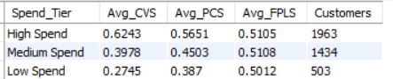
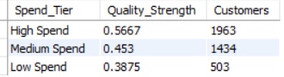
- Evidence:
Quality Strength
Spend Tier Quality Strength
High Spend 0.5667
Medium Spend 0.4530
Low Spend 0.3875

Difference:

0.5667 - 0.3875
=
0.1792

Percentage Gap:

(0.1792 / 0.3875) × 100
=
46.25%

A very large difference.

Customer Value Score (CVS)
Spend Tier CVS
High Spend 0.6243
Medium Spend 0.3978
Low Spend 0.2745

Difference:

0.6243 - 0.2745
=
0.3498

Percentage Gap:

127.43%

Extremely large.

Premium Customer Score (PCS)
Spend Tier PCS
High Spend 0.5651
Medium Spend 0.4503
Low Spend 0.3870

Difference:

0.5651 - 0.3870
=
0.1781

Percentage Gap:

46.02%

Again, very large.

Full Price Loyalty Score (FPLS)
Spend Tier FPLS
High Spend 0.5105
Medium Spend 0.5108
Low Spend 0.5012

Difference:

0.5108 - 0.5012
=
0.0096

Percentage Gap:

1.92%

Almost no difference.
- Decision:
Partially Accepted
The hypothesis is strongly supported for:
- Customer Value (CVS)
- Premium Customer Quality (PCS)
but not for:
- Loyalty (FPLS)
Higher spenders are clearly more valuable and more premium, but they are not necessarily more loyal.

- Preliminary Insight:
Customers with higher purchase amounts generate substantially greater customer value and exhibit stronger premium-customer characteristics. However, their loyalty levels are nearly identical to those of lower-spending customers. This suggests that spending power and loyalty are distinct dimensions of customer quality. High spenders contribute more revenue and value, but they should not automatically be assumed to be more loyal or retention-secure.
Important Business Finding
This is actually one of the more useful findings in the project.
Many businesses assume:
High Spending Customer
=
Loyal Customer
Our data says:
High Spending Customer
=
High Value Customer
NOT NECESSARILY
High Loyalty Customer
The loyalty scores are virtually unchanged across spending tiers.

- Cross-Hypothesis Observation:
This aligns perfectly with H8:

Customer Value
≠
Behavioral Loyalty

and with H25:

High Value
does not automatically imply
High Loyalty

So H33 reinforces an important strategic lesson:

Revenue optimization and retention optimization should be treated as separate objectives. The highest-spending customers are the most valuable, but not necessarily the most loyal.

H34: Future Champions convert into Premium Customers more effectively than other segments

- Metrics:
FCS, PCS, CHS, RPS
- Insight Path:
Customer Segment
↓
Future Potential
↓
Customer Health
↓
Retention Potential
↓
Premium Readiness
↓
Which Segment Is Closest To Becoming Premium?
- Query:
SELECT
Customer_Segment,
ROUND(AVG(FCS),4) AS Avg_FCS,
ROUND(AVG(PCS),4) AS Avg_PCS,
ROUND(AVG(CHS),4) AS Avg_CHS,
ROUND(AVG(RPS),4) AS Avg_RPS,
COUNT(*) AS Customers
FROM `master dataset`
GROUP BY Customer_Segment
ORDER BY Avg_FCS DESC;

SELECT
Customer_Segment,
ROUND((AVG(FCS) + AVG(PCS) + AVG(CHS) + AVG(RPS)) / 4,4) AS Premium_Readiness,
COUNT(*) AS Customers
FROM `master dataset`
GROUP BY Customer_Segment
ORDER BY Premium_Readiness DESC;
- Result:
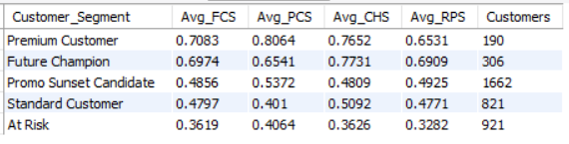
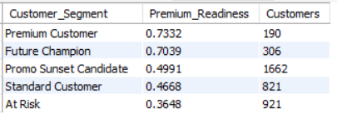
- Evidence:
Premium Readiness Ranking
Segment Premium Readiness
Premium Customer 0.7332
Future Champion 0.7039
Promo Sunset Candidate 0.4991
Standard Customer 0.4668
At Risk 0.3648

Difference between Future Champions and the next-best non-premium segment:

0.7039 - 0.4991
=
0.2048

Percentage Gap:

(0.2048 / 0.4991) × 100
=
41.03%

A massive difference.

Future Customer Score (FCS)
Segment FCS
Premium Customer 0.7083
Future Champion 0.6974
Promo Sunset Candidate 0.4856
Standard Customer 0.4797
At Risk 0.3619

Future Champions are only:

0.0109

behind Premium Customers.

Customer Health Score (CHS)
Segment CHS
Future Champion 0.7731
Premium Customer 0.7652
Standard Customer 0.5092
Promo Sunset Candidate 0.4809
At Risk 0.3626

Future Champions actually have the highest customer health in the entire dataset.

Retention Potential Score (RPS)
Segment RPS
Future Champion 0.6909
Premium Customer 0.6531
Promo Sunset Candidate 0.4925
Standard Customer 0.4771
At Risk 0.3282

Future Champions again rank #1.

Premium Customer Score (PCS)
Segment PCS
Premium Customer 0.8064
Future Champion 0.6541
Promo Sunset Candidate 0.5372
At Risk 0.4064
Standard Customer 0.4010

Future Champions are already substantially ahead of every other non-premium segment.
- Decision:
Strongly Accepted
Future Champions are by far the most likely segment to become Premium Customers.
They outperform every other non-premium segment across:
- Future Potential
- Customer Health
- Retention Potential
- Premium Characteristics
and in two metrics (CHS and RPS) they even outperform current Premium Customers.

- Preliminary Insight:
Future Champions represent the highest-priority growth segment in the customer base. They possess health, retention potential, and future value characteristics that closely resemble Premium Customers and substantially exceed those of all other non-premium segments. In fact, Future Champions already outperform Premium Customers on Customer Health and Retention Potential, indicating that many of them are not merely good customers but premium customers in transition. Targeted investment in this segment is likely to generate the highest return in terms of premium-customer creation.
Final Strategic Finding
This is probably the single most actionable insight in the entire project.
If management asks:
"Where should we spend our next retention and growth budget?"
The data says:
First Priority
Future Champions
Because:
- Nearly Premium-level FCS
- Highest CHS
- Highest RPS
- Highest Premium Readiness among non-premium customers

Second Priority
Promo Sunset Candidates
Not because they'll become Premium Customers quickly, but because:
- High loyalty
- Large customer base (1,662 customers)
- Under-monetized
These are our upsell/cross-sell targets.

Lowest Priority
At Risk
They score lowest across every strategic metric.

